J Mol Biol. 2005 Oct 14;353(1):38-52. 2BXG2BXG (12); ibuprofen,heme1O9X (23), 1H9Z(20),.

Ibuprofen Impairs Allosterically Peroxynitrite Isomerization by Ferric Human Serum Heme-Albumin*
Paolo Ascenzi,Alessandra di Masi,Massimo Coletta¶‖,Chiara Ciaccio¶, Gabriella Fanali**, Francesco P. Nicoletti‡‡,Giulietta Smulevich‖‡‡ and Mauro Fasano**
From the ‡Department of Biology and Interdepartmental Laboratory for Electron Microscopy, University Roma Tre, I-00146 Roma, Italy,
the §National Institute for Infectious Diseases I.R.C.C.S. “Lazzaro Spallanzani,” I-00149 Roma, Italy,
the ¶Department of Experimental Medicine and Biochemical Sciences, University of Roma “Tor Vergata,” I-00133 Roma, Italy,
the ‖Interuniversity Consortium for Research on the Chemistry of Metals in Biological Systems, I-70126 Bari, Italy,
the **Department of Structural and Functional Biology and Center of Neuroscience, University of Insubria, I-21052 Busto Arsizio (VA), Italy, and
the ‡‡Department of Chemistry, University of Firenze, I-50019 Sesto Fiorentino (FI), Italy
↵² To whom correspondence should be addressed: Dept. of Biology, University Roma Tre, Viale Guglielmo Marconi 446, I-00146 Roma, Italy. Tel.: 39-06-5733-3494; Fax: 39-06-5733-6321; E-mail: ascenzi@uniroma3.it.

Abstract Abstract Human serum albumin (HSA) participates in heme scavenging; in turn, heme endows(in:dauz-piešķir) HSA with myoglobin-like reactivity and spectroscopic properties. Here, the allosteric effect of ibuprofen on peroxynitrite isomerization to NO₃⁻ catalyzed by ferric Human serum heme-albumin
(HSA-heme-Fe(III)) is reported. Data were obtained at 22.0 °C. HSA-heme-Fe(III) catalyzes peroxynitrite isomerization in the absence and presence of CO₂; the values of the second order catalytic rate constant (k_{on}) are 4.1 × 10⁵ and 4.5 × 10⁵ M⁻¹ s⁻¹, respectively. Moreover, HSA-heme-Fe(III) prevents peroxynitrite-mediated nitration of free added L-tyrosine. The pH dependence of k_{on} (pK_{a} = 6.9) suggests that peroxynitrous acid reacts preferentially with the
heme-Fe(III) atom, in the absence and presence of CO₂. The HSA-heme-Fe(III)-catalyzed isomerization of peroxynitrite has been ascribed to the reactive pentacoordinated heme-Fe(III) atom. In the absence and presence of CO₂, ibuprofen impairs dose-dependently peroxynitrite isomerization by HSA-heme-Fe(III) and facilitates the nitration of free added L-tyrosine; the value of the dissociation equilibrium constant for ibuprofen binding to HSA-heme-Fe(III)
(L) ranges between 7.7 × 10⁻⁴ and 9.7 × 10⁻⁴ M. Under conditions where [ibuprofen] is ≫L, the kinetics of
HSA-heme-Fe(III)-catalyzed isomerization of peroxynitrite is superimposable to that obtained in the absence of
HSA-heme-Fe(III) or in the presence of non-catalytic HSA-heme-Fe(III)-cyanide complex and HSA. Ibuprofen binding impairs allosterically peroxynitrite isomerization by HSA-heme-Fe(III), inducing the hexacoordination of the heme-Fe(III) atom. These results represent the first evidence for peroxynitrite isomerization by HSA-heme-Fe(III), highlighting the allosteric modulation of HSA-heme-Fe(III) reactivity by heterotropic interaction(s), and outlining the role of drugs in modulating HSA functions. The present results could be relevant for the drug-dependent protective role of HSA-heme-Fe(III) in vivo.

Introduction Human serum albumin (HSA),³ the most abundant protein in plasma (reaching a blood concentration of about [HSA]=7.0 × 10⁻⁴ M), is characterized by an extraordinary ligand binding capacity, providing a depot and carrier for many compounds. HSA affects the pharmacokinetics of many drugs; holds some ligands in a strained orientation, providing their metabolic modification; renders potential toxins harmless, transporting them to disposal sites; accounts for most of the antioxidant capacity of Human serum; and displays (pseudo)enzymatic properties (1–14).
HSA is a single non-glycosylated all-α-chain protein constituted by 585 amino acids, containing three homologous domains (labeled I, II, and III). Each domain is made up by two separate helical subdomains (named A and B), connected by random coils. Terminal regions of sequential domains contribute to the formation of interdomain helices linking domain IB to IIA and domain IIB to IIIA, respectively (Fig. 1) (2, 3, 5, 7, 11, 13,–,25).
The structural organization of HSA provides a variety of ligand binding sites (Fig. 1). According to Sudlow's nomenclature, bulky heterocyclic anions bind preferentially to Sudlow's site I (located in subdomain IIA), whereas Sudlow's site II (located in subdomain IIIA) is preferred by aromatic carboxylates with an extended conformation (Fig. 1). Warfarin and ibuprofen are considered as stereotype ligands for Sudlow's site I and II, respectively (1,–,3, 5, 12, 14, 16, 20,26,–,30).
HSA is able to bind seven equivalents of long-chain fatty acids (FAs) at multiple binding sites (labeled FA1–FA7 in Fig. 1) with different affinity (24, 31). In particular, FA1 is located within the IB subdomain, contacting the IB-IIA polypeptide linker and the long IB-IIA transdomain helix; FA2 is located at the interface between subdomains IA, IB, and IIA; FA3 and FA4 together contribute to Sudlow's site II (i.e. the ibuprofen site in subdomain IIIA); FA5 is located within subdomain IIIB with the ligand polar head oriented toward subdomain IIIA; FA6 is at the interface
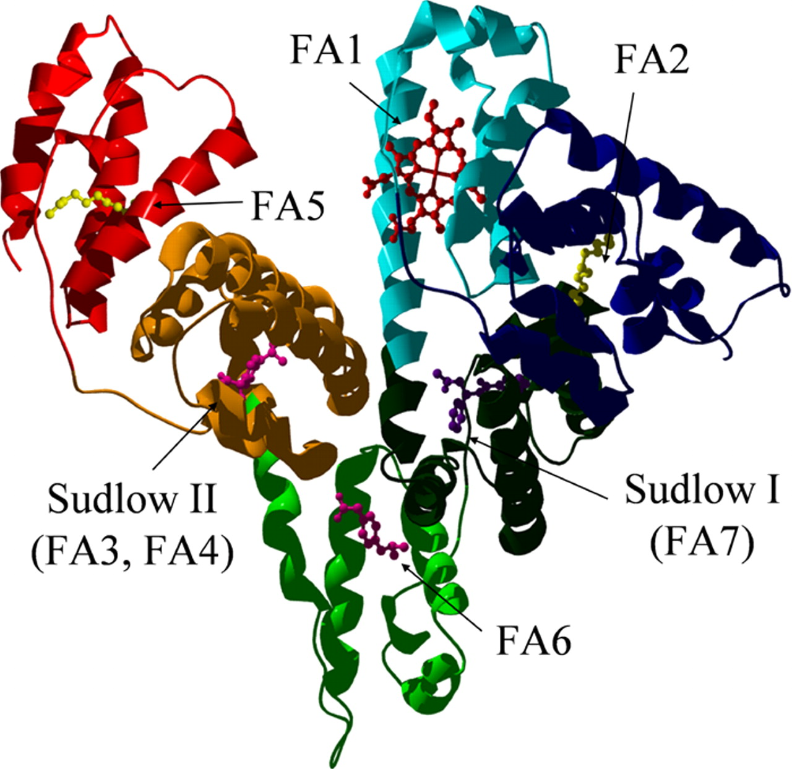 | between subdomains IIA and IIB; FA7 corresponds to Sudlow's site I (i.e. the Warfarin binding site in subdomain IIA). FA2 and FA6 clefts appear to be the secondary binding sites of ibuprofen (1, 3, 12, 14, 16, 18,–,20, 32,–,35).  FIGURE 1. HSA structure. The six subdomains of HSA are coloredas follows. Blue, subdomain IA;cyan, subdomain IB; dark green, subdomain IIA; light green, subdomain IIB; orange, subdomain IIIA; red, subdomain IIIB. The heme (red) fits the primary cleft in subdomain IB, corresponding to FA1. Sudlow's site I (in subdomain IIA, corresponding to FA7) is occupied by Warfarin (purple). Sudlow's site II (in subdomain IIIA, corresponding to FA3-FA4) and FA6 (in subdomain IIB) are occupied by ibuprofen (magenta). Sites FA2 (at the I-IIA interface) and FA5 (in subdomain IIIB) are occupied by myristate (yellow). Atomic coordinates were taken from Protein Data Bank entries 1O9X (23), 1H9Z(20), and 2BXG (12).  The FA1 binding site has been shown to be the primary binding site for heme,
bilirubin, and fusidic acid, an antibiotic that competitively displaces bilirubin from HSA (14, 21, 23). There is increasing evidence that FA1 has evolved to selectively bind heme-Fe(III) with high affinity (K_{d} = 1.0 × 10⁻⁸ M) (21, 23,–,25,36, 37). The tetrapyrrole ring is arranged in a D-shaped cavity limited by Tyr¹³⁸and Tyr¹⁶¹ residues that provide π–π stacking interactions with the porphyrin and supply a donor oxygen (from Tyr¹⁶¹) for the heme-Fe(III) atom. Heme-Fe(III) is secured to HSA by the long IA-IB connecting loop (21, 23,–,25, 36,–,38). In turn, heme endows HSA with myoglobin (Mb)-like reactivity and spectroscopic properties (11, 21, 23, 28, 30, 36,–,55).
Both heme-Fe(III) binding to HSA and HSA-heme-Fe(II) reactivity are modulated allosterically, such that HSA-heme could be considered as a prototype monomeric allosteric macromolecule (21, 23,–,25, 30, 36,–,38, 45, 48, 52, 56). Indeed, the affinity of the heme-Fe(III) for HSA decreases by about 1 order of magnitude upon drug (e.g. Warfarin) binding; on the other hand, heme-Fe(III) binding to HSA decreases the drug affinity by the same extent (57). Further, heme-Fe(III) inhibits ligand binding to Sudlow's site I by stabilizing the basic state of HSA, whereas ligand association to Sudlow's site I impairs HSA-heme-Fe(III) formation by stabilizing the neutral state of HSA (21, 23,–,25, 30, 36, 52,56). Moreover, heme-Fe(III) modulates competitively and allosterically FA binding to HSA, since myristate binding to all FA sites competes with heme-Fe(III) binding to FA1 and at the same time induces the neutral to basic transition, facilitating heme-Fe(III) binding (5, 13, 23, 25, 37). In addition, abacavir and Warfarin have been reported to modulate allosterically peroxynitrite-mediated oxidation of ferrous nitrosylated HSA (HSA-heme-Fe(II)-NO) (50) and NO dissociation from HSA-heme-Fe(II)-NO (51).
Here, ibuprofen, the prototype ligand of Sudlow's site II (1, 3, 26, 58), is reported to impair peroxynitrite⁴ isomerization to NO₃⁻ by HSA-heme-Fe(III), in the absence and presence of CO₂. In the absence of ibuprofen, the pentacoordinated HSA-heme-Fe(III) form catalyzes peroxynitrite isomerization to NO₃⁻, preventing the nitration of free added L-tyrosine. In contrast, ibuprofen induces hexacoordination of the heme-Fe(III) atom of HSA-heme-Fe(III), impairing allosterically peroxynitrite isomerization by HSA-heme-Fe(III) and allowing the nitration of free added
L-tyrosine. These results represent the first evidence for a drug-dependent peroxynitrite scavenging by
HSA-heme-Fe(III), a condition possibly occurring in patients with various hemolytic diseases (59).
EXPERIMENTAL PROCEDURES Materials Hemin (Fe(III)-protoporphyrin IX) chloride was purchased from Sigma. The heme stock solution (5.0 × 10⁻³ M) was prepared by dissolving heme-Fe(III) in 1.0 × 10⁻² M NaOH (60). The heme-Fe(III) concentration was determined spectrophotometrically at 535 nm, after converting heme-Fe(III) to the heme-Fe(III)-bisimidazolate derivative by adding 1.0 M imidazole, in SDS micelles (ϵ_{535 nm} = 14.5 × 10³ M⁻¹ cm⁻¹) (61).
HSA (≥96%, essentially fatty acid-free) was obtained from Sigma. To remove hydrophobic ligands, HSA was dissolved in water, acidified to pH 3.5 with acetic acid, and treated for 2 h with activated charcoal at room temperature. After charcoal removal by centrifugation, the pH was brought to 7.0 with aqueous ammonia (62). The HSA concentration was determined spectrophotometrically at 280 nm (ϵ_{280 nm} = 38.2 × 10³ M⁻¹ cm⁻¹) (60). The HSA stock solution
(2.0 × 10⁻⁴ M) was prepared by diluting the hydrophobic ligand-free HSA solution with the 2.0 × 10⁻² M sodium phosphate buffer, at pH 7.2. The HSA-heme-Fe(III) stock solution (2.0 × 10⁻⁴ M) was prepared by adding a 0.9-fold molar defect of the heme-Fe(III) stock solution to the HSA solution (2.0 × 10⁻² M sodium phosphate buffer, pH 7.2) (30, 37, 42, 44, 50, 54, 55, 60, 63). The HSA and HSA-heme(III) stock solutions were diluted in the 2.0 × 10⁻¹ M sodium phosphate buffer at the desired pH value (ranging between 6.2 and 8.1) and concentration (ranging between 1.0 × 10⁻⁵ and 1.0 × 10⁻⁴ M).
Peroxynitrite was synthesized from KO₂ and •NO and from HNO₂ and H₂O₂ and stored in small aliquots at
-80.0 °C (64, 65). The peroxynitrite stock solution (2.0 × 10⁻³ M) was diluted immediately before use with degassed
5.0 × 10⁻² M NaOH to reach the desired concentration (50, 66⇓–,69). Nitrate and nitrite contaminations were in the range of 0–7% and 8–19% of the peroxynitrite concentration, respectively (see “Methods”). The concentration of peroxynitrite was determined spectrophotometrically prior to each experiment by measuring the absorbance at 302 nm
(ϵ_{302 nm} = 1.705 × 10³ M⁻¹ cm⁻¹) (64, 65).
Experiments in the presence of CO₂, between pH 6.2 and 8.1, were carried out by adding to the protein solutions the required amount of a 5.0 × 10⁻¹ M NaHCO₃ solution. After the addition of bicarbonate, the protein solutions were allowed to equilibrate for at least 5 min. For the experiments carried out in the absence of CO₂, all solutions were thoroughly degassed and kept under nitrogen or helium (50, 66⇓–,69).
Experiments in the presence of cyanide at pH 7.2 were carried out by adding 2.0 × 10⁻¹ M cyanide to the
HSA-heme(III) and peroxynitrite/ibuprofen/L-tyrosine solutions, in the absence and presence of CO₂. This cyanide concentration allowed to obtain more than 90% of HSA-heme-Fe(III)-cyanide complex (HSA-heme-Fe(III)-CN) (43, 52).
Ibuprofen was obtained from Sigma. The ibuprofen stock solution (1.0 × 10⁻² M) was prepared by dissolving the drug in 2.0 × 10⁻² M phosphate buffer at pH 7.2 (30). The final ibuprofen concentration ranged between 5.0 × 10⁻⁵ and 1.0 × 10⁻² M.
L-Tyrosine and nitro-L-tyrosine were obtained from Sigma. L-tyrosine and nitro-L-tyrosine were dissolved in
1.0 × 10⁻¹ M phosphate buffer, at pH 7.2; the finalL-tyrosine concentration was 1.0 × 10⁻⁴ M (67, 70).
All of the other chemicals were obtained from Sigma and Merck. All products were of analytical or reagent grade and were used without further purification.
Methods The kinetics of peroxynitrite isomerization in the absence and presence of HSA-heme-Fe(III), HSA-heme-Fe(III)-CN, HSA, CO₂, ibuprofen, and L-tyrosine was recorded with the SMF-20 and SMF-400 rapid mixing stopped-flow apparatus (Bio-Logic SAS, Claix, France). The light path of the observation cuvette was 10 mm, and the dead time was 1.4 ms. The kinetics was monitored at 302 nm, the characteristic absorbance maximum of peroxynitrite (64, 65). Kinetic data were obtained in the absence and presence of CO₂ (final concentration, 1.2 × 10⁻³ M) and ibuprofen (final concentration, 5.0 × 10⁻⁵ to 1.0 × 10⁻² M) by rapid mixing the protein solution (final concentration,
5.0 × 10⁻⁶ to 5.0 × 10⁻⁵ M) or the buffer solution (1.0 × 10⁻¹ M phosphate buffer) with the peroxynitrite solution (final concentration, 2.5 × 10⁻⁵ to 2.5 × 10⁻⁴ M). The kinetics was obtained at 22.0 °C and between pH 6.2 and 8.1
(1.0 × 10⁻¹ M phosphate buffer); the pH was always measured at the end of the reaction. No gaseous phase was present.
The kinetics of peroxynitrite isomerization in the absence and presence of HSA-heme-Fe(III) was analyzed in the framework of the minimum reaction Schemes 1 and 2, respectively (67, 70), HOONO —k_{o}→ NO₃⁻+ H⁺ ; SCHEME 1
HSA-heme-Fe(III) + HOONO —k_{on}→ ; HSA-heme-Fe(III)-OONO —fast→ ; HSA-heme-Fe(III) + NO₃⁻+ H⁺
Values of the first-order rate constant for peroxynitrite isomerization in the presence of HSA-heme-Fe(III)-CN, HSA, and 1.0 × 10⁻¹ M phosphate buffer (i.e. k₀ or k₀i in the absence and presence of ibuprofen, respectively) and of the pseudo-first-order rate constant for HSA-heme-Fe(III)-mediated peroxynitrite isomerization (i.e. k_{obs} or k_{obs}i in the absence and presence of ibuprofen, respectively) have been determined, in the absence and presence of CO₂, between pH 6.2 and 8.1 at 22.0 °C, from the analysis of the time-dependent absorbance decrease at 302 nm, according to Equation 1 (67, 69⇓⇓⇓–,74),where k is k₀ or k_{obs} in the absence of ibuprofen and k₀i or k_{obs}i in the presence of ibuprofen.
Values of the second-order rate constant for HSA-heme-Fe(III)-mediated peroxynitrite isomerization (i.e. k_{on} or k_{on}i in the absence and presence of ibuprofen, respectively) have been determined, in the absence and presence of CO₂, between pH 6.2 and 8.1 at 22.0 °C, from the linear dependence of k_{obs} ork_{obs}i on the HSA-heme-Fe(III) concentration according to Equations 2 and 3 (67,70, 71, 73),
The pH dependence of k₀ and k_{on} for peroxynitrite isomerization in the absence and presence of HSA-heme-Fe(III) allows us to obtain, in the absence of ibuprofen and both in the absence and presence of CO₂, at 22.0 °C, the values of pK_{a}, k_{lim(top)} and k_{lim(bottom)} (67, 70,–,72) according to Equation 4,where k is k₀ or k_{on}, and k_{lim(top)} represents the top asymptotic value of k under conditions where pH ≪ pK_{a}, and Equation 5,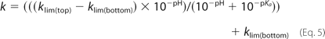where k is k₀ or k_{on}, and k_{lim(top)} and k_{lim(bottom)} represent the asymptotic values of k under conditions where pH ≪ pK_{a} or pH ≫ pK_{a}, respectively.
The value of the dissociation equilibrium constant for ibuprofen binding to HSA-heme-Fe(III) (L) was determined, at pH 7.2, from the dependence of k_{on}i on the ibuprofen concentration (ranging between 5.0 × 10⁻⁵ and 1.0 × 10⁻² M). The effect of ibuprofen concentration on k_{on}i was analyzed according to Equation 6(30, 51, 71),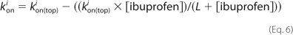where k_{on(top)}i represents the asymptotic value of k_{on}i under conditions where [ibuprofen] = 0 (i.e. k_{on(top)}i = k_{on}).
NO₂⁻ and NO₃⁻ analysis was carried out spectrophotometrically at 543 nm by using the Griess reagent and VCl3 to catalyze the conversion of NO₃⁻ to NO₂⁻, as described previously (70, 75, 76). Calibration curves were obtained by measuring 4–8 standard sodium nitrite and sodium nitrate solutions in 1.0 × 10⁻¹ M phosphate buffer, pH 7.2, and 22.0 °C. The samples were prepared by mixing 500 μl of a HSA-heme-Fe(III) solution (initial concentration, 1.0 × 10⁻⁴ Min 2.0 × 10⁻¹ M phosphate buffer, pH 7.2) with 500 μl of a peroxynitrite solution (initial concentration, 4.0 × 10⁻⁴ M in 1.0 × 10⁻² M NaOH) while vortexing, at 22.0 °C, in the absence and presence of CO₂ (1.2 × 10⁻³ M) and ibuprofen (2.5 × 10⁻³ M). The reaction mixture was analyzed within ∼10 min. At least four separate experiments were carried out.
The reaction of peroxynitrite with free L-tyrosine was carried out at pH 7.2 and 22.0 °C by adding 0.2 ml of an alkaline (1.0 × 10⁻² M NaOH) ice-cooled solution of peroxynitrite (2.0 × 10⁻³ M) to 1.8 ml of a buffered (1.0 × 10⁻¹ M phosphate buffer) solution of L-tyrosine (final concentration, 1.0 × 10⁻⁴ M) in the absence and presence of HSA-heme-Fe(III), HSA-heme-Fe(III)-CN, HSA (final concentration, 5.0 × 10⁻⁶ to 5.0 × 10⁻⁵ M), ibuprofen (final concentration, 2.0 × 10⁻⁴ to 5.0 × 10⁻³ M), and CO₂ (final concentration, 1.2 × 10⁻³ M), as previously reported (67, 70).
The amount of nitro-L-tyrosine was determined by HPLC, as reported previously (67, 70). The chromatographic system consisted of a Waters 600 pump and a Waters autosampler 717 PLUS equipped with a spectrophotometric UV-visible dual wavelength system, Waters 2487 (Waters, Milford, MA). Nitro-L-tyrosine separation was performed at 24.0 °C on the Grace Vydac 218TP54 Protein&Peptide C18 column (250 × 4.6 mm) equipped with a Grace Vydac guard cartridge filled with the same packing material (Grace Vydac, Columbia, MD). The mobile phase was composed of solutions A (0.07% trifluoroacetic acid in H₂O) and B (0.07% trifluoroacetic acid in acetonitrile). Both solutions were degassed by purging with helium. The injection volume was 20 μl. Nitro-L-tyrosine was eluted (7.48 ± 0.05 min after injection) by keeping the amount of solvent B constant (5%) in the first 2 min and then by using an increasing linear gradient of B from 5 to 10% between 2 and 10 min and from 10 to 80% between 10 and 15 min. Nitro-L-tyrosine was detected at 220, 280, 350, and 400 nm. Nitro-L-tyrosine was quantified by measuring a calibration curve of seven nitro-L-tyrosine standard solutions. The Millenium software (Waters) was used to pilot the HPLC instrument and to process the data (i.e. area integration, calculation, and plotting of chromatograms) throughout the method validation and sample analysis.
The value of the dissociation equilibrium constant for ibuprofen binding to HSA-heme-Fe(III) (L) was determined, at pH 7.2 and 22.0 °C, from the dependence of the relative yield of nitro-L-tyrosine formed from the reaction of peroxynitrite with free L-tyrosine (Y) on the drug concentration ([ibuprofen], ranging between 2.0 × 10⁻⁴ and 5.0 × 10⁻³ M). The effect of the ibuprofen concentration on Y was analyzed according to Equation 7 (30, 51, 71),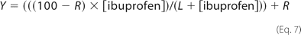where R corresponds to Y in the absence of ibuprofen.
The value of the dissociation equilibrium constant for ibuprofen binding to HSA-heme-Fe(III) (L) was also obtained spectrophotometrically at 404 nm (by a Cary 50 Bio spectrophotometer; Varian Inc., Palo Alto, CA), using an optical cell with 1.0-cm path length, at 22.0 °C. Small aliquots of the 1.2 × 10⁻² M heme-Fe(III) and 1.0 × 10⁻³ M HSA solutions were diluted in the optical cell in 1.0 × 10⁻¹ Mphosphate buffer, 10% DMSO, pH 7.0, to a final HSA-heme-Fe(III) concentration of 1.0 × 10⁻⁵ M. Then small aliquots of the 1.0 × 10⁻³ M ibuprofen solution were added to the HSA-heme-Fe(III) solution, and the absorbance spectra were recorded after incubation for a few minutes after each addition. Ibuprofen binding to HSA-heme-Fe(III) was analyzed by plotting the Soret band absorbance change (ΔA) as a function of the ibuprofen concentration. Data were analyzed according to Equation 8 (30, 51, 71),where ΔA_{max} is the absorbance change at saturating ibuprofen concentration.
Kinetic and thermodynamic data were analyzed using the MatLab program (The Math Works Inc., Natick, MA). The results are given as mean values of at least four experiments ± S.D.

RESULTS HSA-Heme(III) Catalyzes Peroxynitrite Isomerization
The kinetics of peroxynitrite isomerization, both in the absence and presence of HSA-heme-Fe(III), HSA-heme-Fe(III)-CN, HSA, and CO₂, was recorded by a single-wavelength stopped-flow apparatus. Under all of the experimental conditions, a decrease of the absorbance at 302 nm was observed, as previously reported (67, 69, 70, 72,–,74). The kinetics of peroxynitrite isomerization was fitted to a single-exponential decay for more than 97% of its course (supplemental Fig. S1). According to the literature (67, 70), this indicates that no intermediate species (e.g. HSA-heme-Fe(III)-OONO; see Scheme 2) accumulate(s) in the course of peroxynitrite isomerization. In particular, the formation of the transient HSA-heme-Fe(III)-OONO species represents the rate-limiting step in catalysis, the conversion of the HSA-heme-Fe(III)-OONO complex to HSA-heme-Fe(III) and NO₃⁻ being faster by at least 1 order of magnitude.
In the absence of CO₂, the observed rate constant for HSA-heme-Fe(III)-catalyzed isomerization of peroxynitrite (k_{obs}) increases linearly with the HSA-heme-Fe(III) concentration over the whole pH range explored (Fig. 2A). The analysis of data reported in Fig. 2A, according to Equation 2, allowed the determination of values of the first-order rate constant for peroxynitrite isomerization in the absence of HSA-heme-Fe(III) (k₀; corresponding to the y intercept of the linear plots) and of the second-order rate constant for peroxynitrite isomerization by HSA-heme-Fe(III) (k_{on}; corresponding to the slope of the linear plots). Values of k₀ for peroxynitrite isomerization in the absence of HSA-heme-
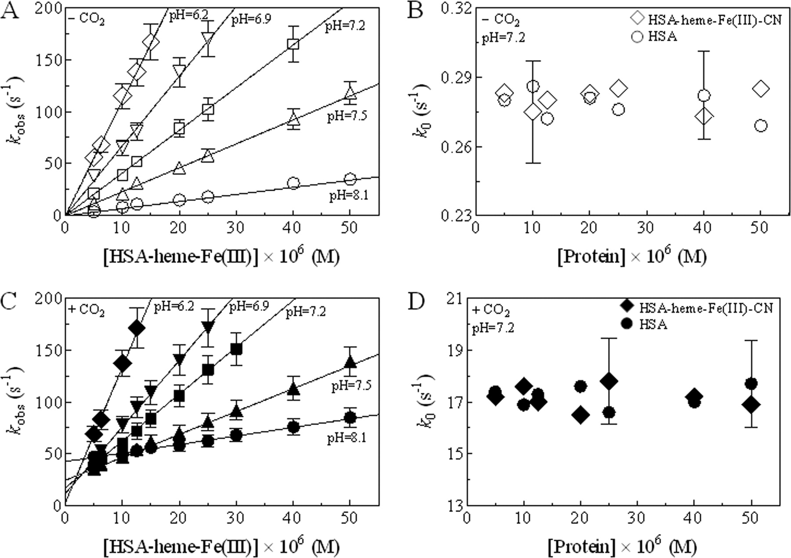 | Fe(III) (Table 1) are in good agreement with those obtained in the presence of HSA-heme-Fe(III)-CN and HSA (Fig. 2B) and reported in the literature (67, 70, 72, 74).  FIGURE 2. Dependence of the (pseudo-)first-order rate constant for peroxynitrite isomerization on the HSA-heme-Fe(III) (k_{obs}; A andC), HSA-heme-Fe(III)-CN (k₀; B and D), and HSA (k₀;B and D) concentration, in the absence (A and B) and presence (C and D) of CO₂a at 22.0 °C. The peroxynitrite concentration was 2.5 × 10⁻⁴ M. The CO₂ concentration was 1.2 × 10⁻³ M. The continuous lines in A and C were calculated according toEquation 2 with values of k₀ and k_{on} given in Table 1. Where not shown, the S.D. value is smaller than the symbol in A and C. For clarity, the S.D. is shown for two k₀ values in B and D.
TABLE 1pH dependence of k₀ andk_{on} values for peroxynitrite isomerization in the absence and presence of
HSA-heme-Fe(III) and CO₂, at 22.0 °C.
1.0 × 10⁻¹ M sodium phosphate buffer was used. The CO₂ concentration was 1.2 × 10⁻³ M. In italic type are shown the values ofk₀ for peroxynitrite isomerization obtained in the absence of HSA-heme-Fe(III). In normal type are shown values of k₀ for HSA-heme-Fe(III)-catalyzed peroxynitrite isomerization.  Because of the physiological relevance attributed to the reaction between CO₂ and peroxynitrite (79, 74, 77,–,79), the effect of the physiological concentration of CO₂ on peroxynitrite isomerization by HSA-heme-Fe(III), HSA-heme-Fe(III)-CN, and HSA has been investigated. As shown in Fig. 2C, HSA-heme-Fe(III) catalyzes the isomerization of peroxynitrite in a concentration-dependent linear fashion. The analysis of data reported in Fig. 2C, according to Equation 2, allowed the determination of values of the first-order rate constant for peroxynitrite isomerization in the absence of HSA-heme-Fe(III) (k₀; corresponding to the yintercept of the linear plots) and of the second-order rate constant for peroxynitrite isomerization by HSA-heme-Fe(III) (k_{on}; corresponding to the slope of the linear plots). In the presence of CO₂, values of k₀ for peroxynitrite isomerization in the absence of HSA-heme-Fe(III) (Table 1) are in good agreement with those obtained in the presence of HSA-heme-Fe(III)-CN and HSA (Fig. 2D) and reported in the literature (67, 70, 74).  Values of k_{on} for HSA-heme-Fe(III)-catalyzed isomerization of peroxynitrite are essentially unaffected by CO₂ (Table 1). In contrast, values of k₀ for peroxynitrite | pH | k₀ |  | k_{on}
 | pH | Without CO₂ | With CO₂ | Without CO₂ | With CO₂
 |  | s⁻1 |  | M⁻1 s⁻1
 | 6.2 | 0.67 | 4.1
 |  | 0.69 | 3.9 | 1.1 × 10⁶ | 1.3 × 10⁶
 | 6.4 | 0.64 | 6.2
 |  | 0.62 | 6.1 | 9.8 × 10⁵ | 9.6 × 10⁵
 | 6.7 | 0.43 | 8.9
 |  | 0.48 | 9.1 | 7.9 × 10⁵ | 8.1 × 10⁵
 | 6.9 | 0.35 | 11.9
 |  | 0.38 | 12.3 | 6.7 × 10⁵ | 6.4 × 10⁵
 | 7.2 | 0.28 | 17.4
 |  | 0.26 | 17.8 | 4.1 × 10⁵ | 4.5 × 10⁵
 | 7.5 | 0.11 | 25.3
 |  | 0.14 | 24.9 | 2.3 × 10⁵ | 2.2 × 10⁵
 | 7.8 | 0.086 | 32.9
 |  | 0.078 | 33.5 | 1.3 × 10⁵ | 1.5 × 10⁵
 | 8.1 | 0.046 | 43.7
 |  | 0.041 | 42.8 | 6.8 × 10⁴ | 8.2 × 10⁴
isomerization obtained in the presence of HSA-heme-Fe(III)-CN, HSA, and CO₂ are 10–100 times higher than those obtained in the absence of CO₂ (Table 1). The lack of a CO₂-linked effect on peroxynitrite isomerization by HSA-heme-Fe(III) is probably related to the fact that peroxynitrite reacts faster with HSA-heme-Fe(III) (k_{on} = 4.1 × 10⁵ and 4.5 × 10⁵ M⁻¹ s⁻¹, in the absence and presence of CO₂, respectively) (Table 1) than with CO₂ (the second-order rate constant being 3 × 10⁴ M⁻¹ s⁻¹) (74, 79).
To confirm the catalytic effect of HSA-heme-Fe(III) on peroxynitrite isomerization, the dependence of k_{obs} and k₀ on the peroxynitrite concentration was determined in the absence and presence of HSA-heme-Fe(III), HSA-heme-Fe(III)-CN, HSA, and CO₂ concentration, at pH 6.2 (data not shown), 7.2 (Fig. 3), and 8.1 (data not shown). Under all the experimental conditions, values of k_{obs}and k₀ for peroxynitrite isomerization slightly decrease upon increasing peroxynitrite concentration. In contrast, the amplitude of the kinetics increases as a function of the peroxynitrite concentration (data not shown). The decrease ofk_{obs} and k₀ values upon increasing peroxynitrite concentration at fixed HSA-heme-Fe(III) concentration in the absence and presence of CO₂ (Fig. 3) is reminiscent of what has been reported for peroxynitrite isomerization by Human Hb-Fe(III) and horse heart Mb-Fe(III) (70). This behavior has been proposed to reflect the occurrence of the peroxynitrite/peroxynitrous acid adduct at [peroxynitrite] > 5.0 × 10⁻⁵ M, around neutrality (70). Accordingly, the decrease of k_{obs} and k₀ values upon increasing the peroxynitrite concentration may reflect
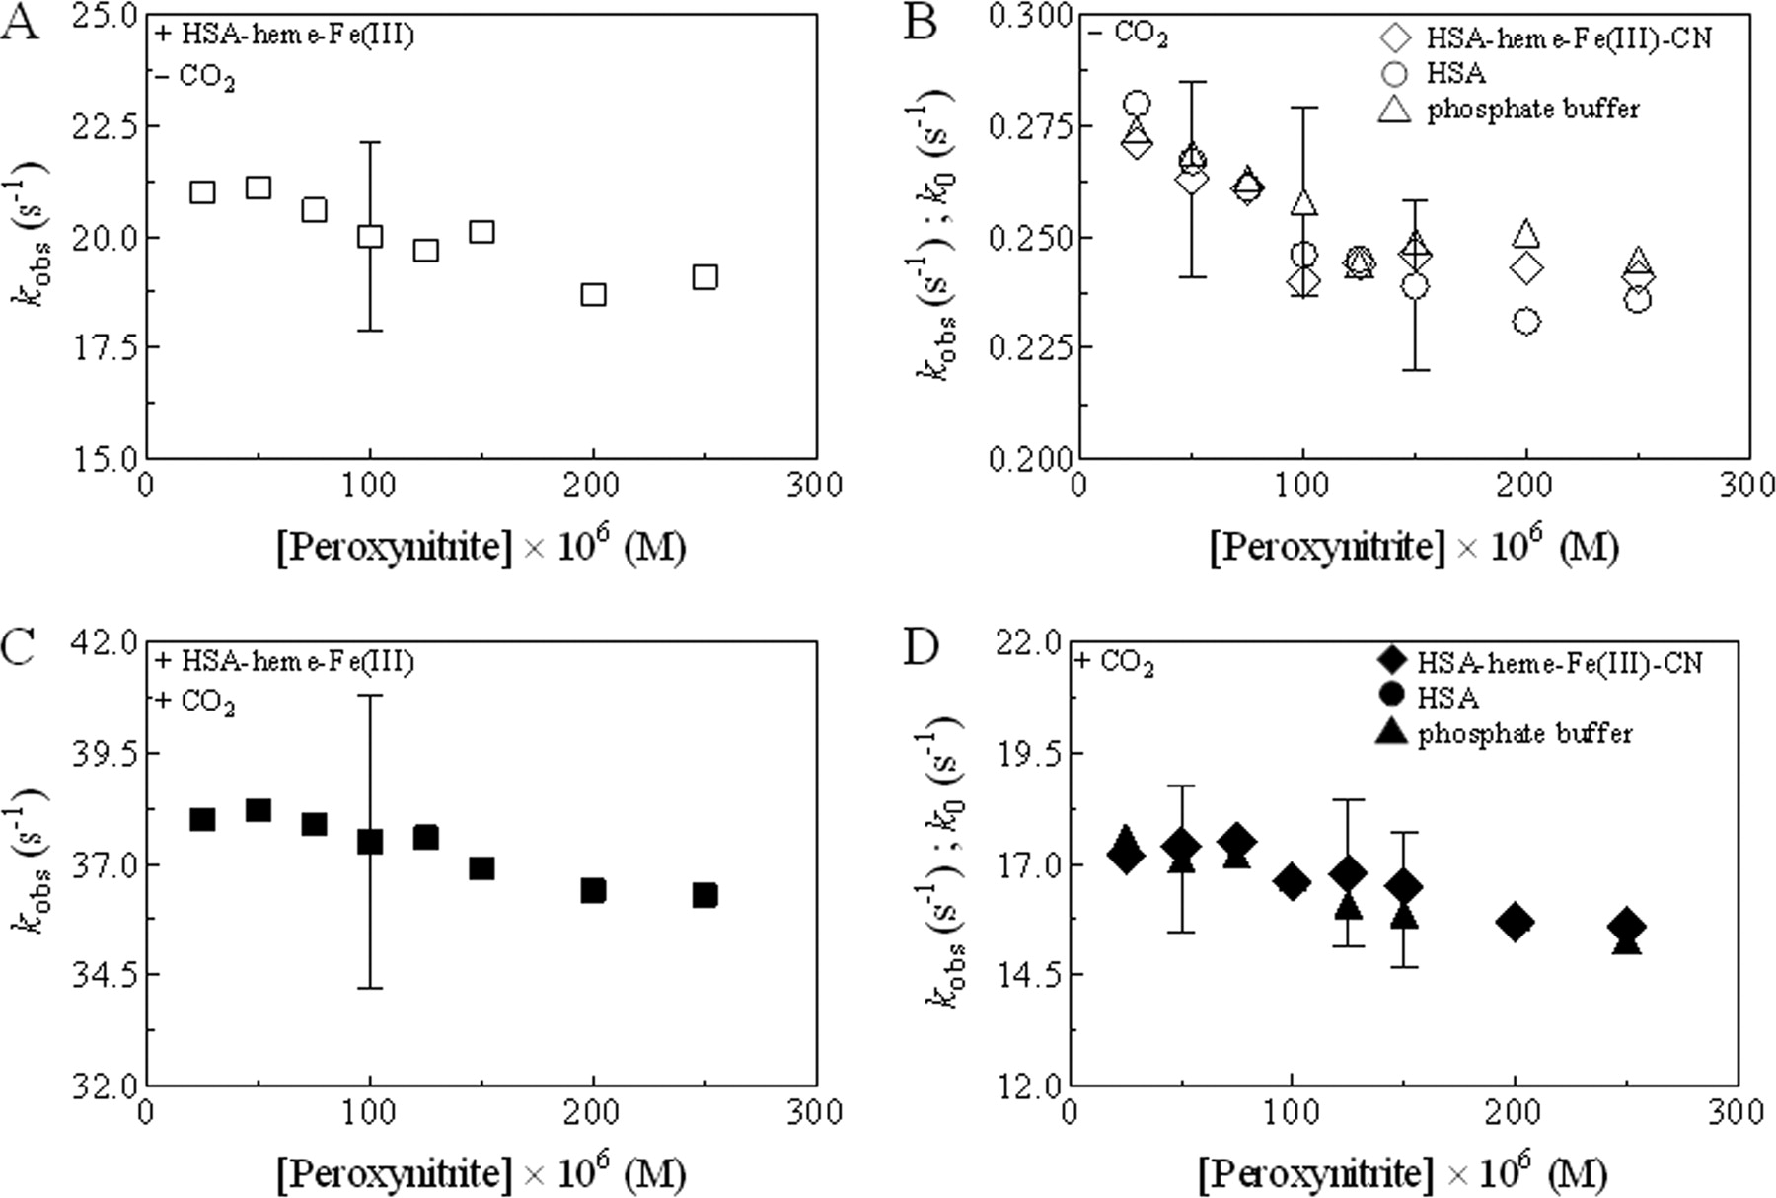 | either the slow HSA-heme-Fe(III)-mediated decomposition of the peroxynitrite/peroxynitrous acid adduct or the slow dissociation of the peroxynitrite/peroxynitrous acid adduct preceding HSA-heme-Fe(III)-catalyzed peroxynitrite isomerization.  FIGURE 3. Effect of peroxynitrite concentration on values of the (pseudo-)first-order rate constant for peroxynitrite isomerization in the presence of HSA-heme-Fe(III) (k_{obs}; A andC), HSA-heme-Fe(III)-CN (k_{obs}; B and D), HSA (k_{obs};B and D), and 1.0 × 10⁻¹ Mphosphate buffer (k₀; B and D) in the absence (A and B) or presence (C and D) of CO₂, at pH 7.2 and 22.0 °C. The HSA-heme-Fe(III), HSA-heme-Fe(III)-CN, and HSA concentrations were 5.0 × 10⁻⁶ M. The CO₂ concentration was 1.2× 10⁻³ M.
For clarity, the S.D. value was shown for prototypical k_{obs} and k₀ values in each panel.
To highlight the role of the heme-Fe(III) atom to catalyze peroxynitrite isomerization, the effect of HSA-heme-Fe(III)-CN and HSA concentration on the isomerization of peroxynitrite was investigated in the absence and presence of CO₂. As shown in Fig. 2, B and D, HSA-heme-Fe(III)-CN and HSA do not affect the peroxynitrite isomerization kinetics. Therefore, the acceleration of the peroxynitrite isomerization rate by HSA-heme-Fe(III) could be due to the reaction of peroxynitrite with the heme-Fe(III) atom, as reported for Human Hb-Fe(III) and horse heart Mb-Fe(III) (70).
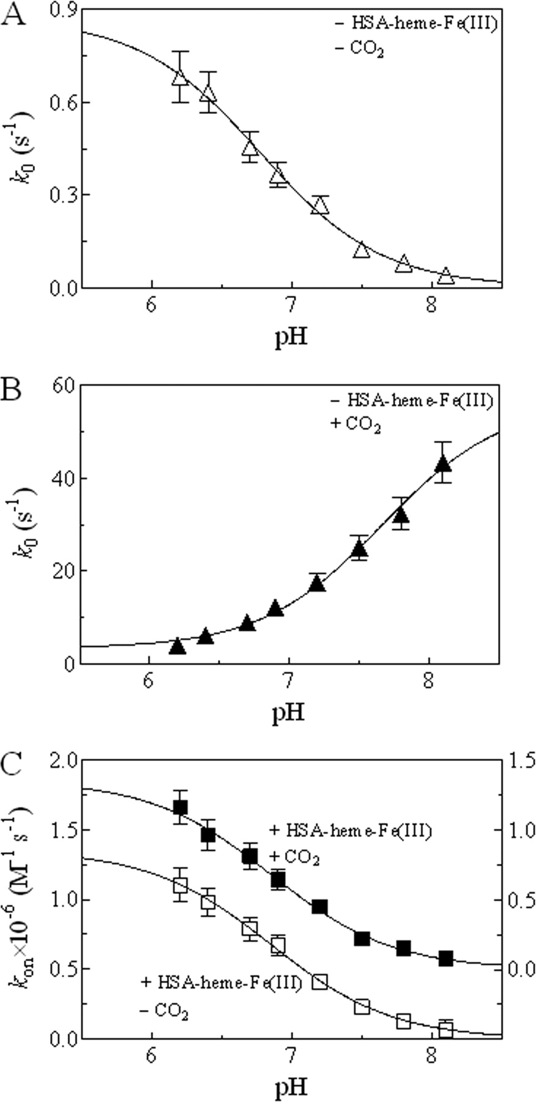 | The pH dependence of k₀ and k_{on} for peroxynitrite isomerization, in the absence and presence of HSA-heme-Fe(III) and CO₂, was examined to identify tentatively the species that preferentially react(s) with HSA-heme-Fe(III). Values of k₀ andk_{on} shown in Fig. 4 were derived from data reported in Fig. 2, A and C, and are listed in Table 1. Values of k₀ for peroxynitrite isomerization in the absence of HSA-heme-Fe(III) and CO₂ decrease upon increasing pH from 6.2 to 8.1 (Fig. 4A). In contrast, values of k₀ for peroxynitrite isomerization in the absence of HSA-heme-Fe(III) but in the presence of CO₂ increase upon raising the pH from 6.2 to 8.1 (Fig. 4B). In the absence and presence of CO₂, the pH dependence of k_{on}values for HSA-heme-Fe(III)-mediated isomerization of peroxynitrite (Fig. 4C) is closely similar to that of k₀ for peroxynitrite isomerization in the absence of HSA-heme-Fe(III) and CO₂ (Fig. 4A). The analysis of data reported in Fig. 4, according to Equations 4 and 5, allowed the estimation of pK_{a} values for the pH dependence of k₀ and k_{on} values for peroxynitrite isomerization in the absence and presence of HSA-heme-Fe(III) and CO₂.  FIGURE 4. Effect of pH on the first-order rate constant for peroxynitrite isomerization (k₀) in the absence (A) and presence (B) of CO₂ and on the second-order rate constant for HSA-heme-Fe(III)-mediated peroxynitrite isomerization (k_{on}) in the absence (left) and presence (right) of CO₂ (C), at 22.0 °C. Values of k₀in A and B are the average of those obtained from experiments of peroxynitrite isomerization in the absence and presence of HSA-heme-Fe(III) (see Table 1). The peroxynitrite concentration was 2.5 × 10⁻⁴ M. The CO₂ concentration was 1.2 × 10⁻³ M. The continuous line in A was calculated according to Equation 4 with pK_{a} = 6.8
and k_{lim(}top₎ = 0.86 s⁻¹. The continuous line in B was calculated according to Equation 5 with pK_{a} = 7.6, k_{lim(top)} = 55.3 s⁻¹, and k_{lim(bottom)} = 3.1 s⁻¹. Both continuous lines in C were calculated according to Equation 4 with pK_{a} = 6.9 and k_{lim(top)} = 1.4 × 10⁶ M⁻¹ s⁻¹. Where not shown, the S.D. value is smaller than the symbol.
The pH dependence of k₀ for peroxynitrite isomerization in the absence of both HSA-heme-Fe(III) and CO₂ (pK_{a} = 6.8) (Fig. 4A) and of k_{on} for peroxynitrite isomerization by HSA-heme-Fe(III) in the absence and presence of CO₂ (pK_{a} = 6.9) (Fig. 4C) is similar. The pK_{a} value (6.8) for the pH dependence of k₀ for peroxynitrite isomerization in the absence of both HSA-heme-Fe(III) and CO₂ here determined is in excellent agreement with pK_{a} values reported in the literature (74). In contrast, the pH dependence of k₀ for peroxynitrite isomerization in the absence of HSA-heme-Fe(III) but in the presence of CO₂ (pK_{a} = 7.6) (Fig. 4B) is different from that of k₀ for peroxynitrite isomerization in the absence of both HSA-heme-Fe(III) and CO₂ (pK_{a} = 6.8) (Fig. 4A) and of k_{on} for peroxynitrite isomerization by HSA-heme-Fe(III) in the absence and presence of CO₂ (pK_{a} = 6.9) (Fig. 4C).
According to the literature (67, 70), the close similarity of the pH dependence ofk₀ for peroxynitrite isomerization in the absence of both HSA-heme-Fe(III) and CO₂ (pK_{a} = 6.8) (Fig. 4A) and of k_{on} for peroxynitrite isomerization by HSA-heme-Fe(III) in the absence and presence of CO₂ (pK_{a} = 6.9) (Fig. 4C) suggests that in all cases, HOONO is the species that reacts preferentially with the heme-Fe(III) atom. Conversely, the different pK_{a} value observed for peroxynitrite isomerization in the presence of CO₂ and in the absence of HSA-heme-Fe(III) (pK_{a}= 7.6) (Fig. 4B) could indicate that the species undergoing the isomerization is a transient highly reactive intermediate(s) formed by the reaction of peroxynitrite with CO₂. Since peroxynitrite has been reported to react with CO₂, leading to the formation of an adduct whose composition is believed to be ONOOC(O)O⁻(named 1-carboxylato-2-nitrosodioxidane) (74, 79), this might be the transient species that then converts to NO₃⁻ and CO₂ either directly or by transient formation of trioxocarbonate(•1-) (CO₃̇̄) and •NO₂. On the other hand, the similar pK_{a} values for peroxynitrite isomerization by HSA-heme-Fe(III), both in the absence and in the presence of CO₂ (pK_{a} = 6.9), indicates that peroxynitrite reacts with HSA-heme-Fe(III) as HOONO.
Ibuprofen Impairs HSA-Heme-Fe(III)-mediated Isomerization of Peroxynitrite In the absence and presence of CO₂, ibuprofen impairs dose-dependently HSA-heme-Fe(III)-mediated isomerization of peroxynitrite (Fig. 5). Mixing HSA-heme-Fe(III) with peroxynitrite, in the presence of ibuprofen and in the absence and presence of CO₂, brings about a decrease of the absorbance at 302 nm (supplemental Fig. S2, A and B). Moreover, the kinetics of peroxynitrite isomerization by HSA-heme-Fe(III), in the presence of ibuprofen and in the absence and presence of CO₂, was fitted to a single-exponential decay for more than 97% of its course (supplemental Fig. S2, A and B). These findings agree with the results concerning peroxynitrite isomerization in the absence of ibuprofen (see above and supplemental Fig. S1). FIGURE 5. Effect of the ibuprofen concentration on the dependence of the pseudo-first-order rate constant for
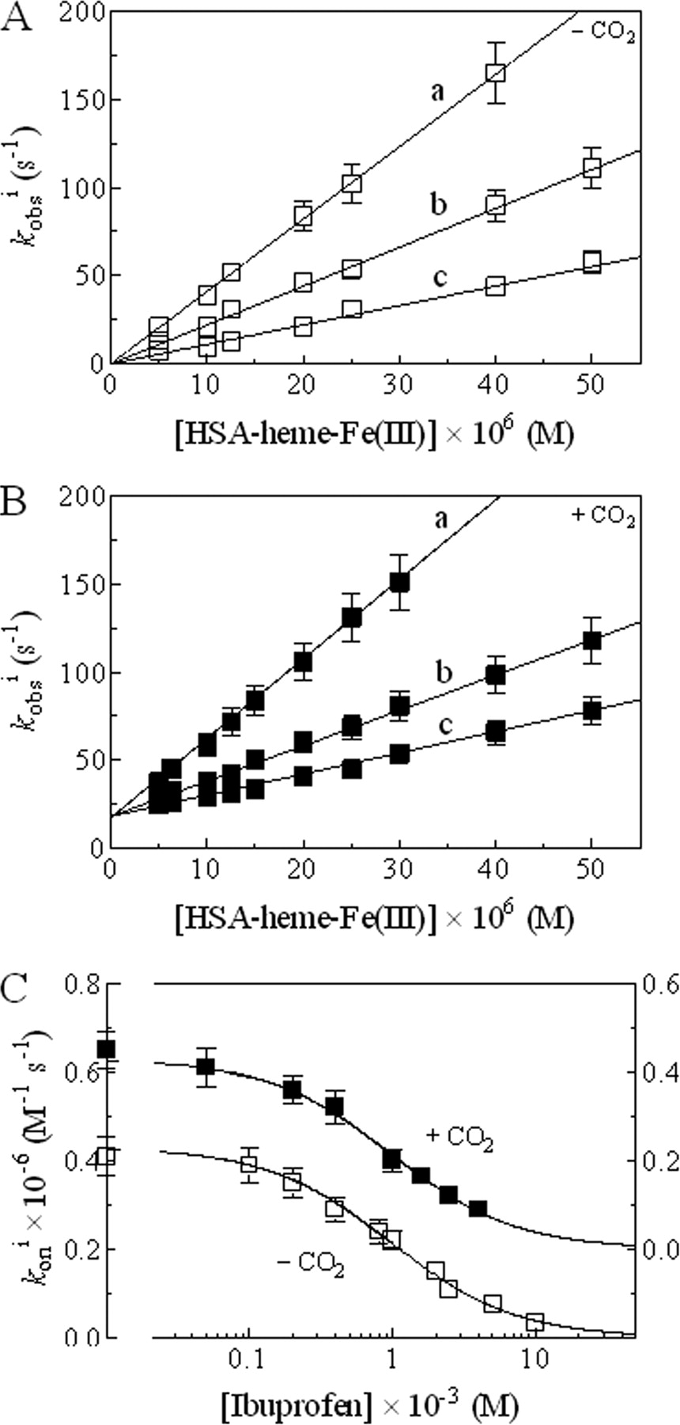 | peroxynitrite isomerization (k_{obs}i) on the HSA-heme-Fe(III) concentration, in the absence (A) and presence (B) of CO₂, at pH 7.2 and 22.0 °C. Data reported in panels A and B were obtained at [ibuprofen] = 0.0 M (a), 1.0 × 10⁻³ M (b), and  2.5 × 10⁻³ M(c). The continuous lines in A and B were calculated according toEquation 3 with values of k_{on}i and k₀i given in Table 2. Shown is the effect of the ibuprofen concentration on the second-order rate constant for  HSA-heme(III)-catalyzed isomerization of peroxynitrite (k_{on}i) in the absence (left) and presence (right) of CO₂ (C). Both continuous lines were calculated according to Equation 4 with L = 9.7 × 10⁻⁴ M and k_{on(top)}i = 4.3 × 10⁵ M⁻¹ s⁻¹. Where not shown, the S.D. value is smaller than the symbol.  The observed rate constant for HSA-heme-Fe(III)-catalyzed isomerization of peroxynitrite (k_{obs}i) increases linearly with the HSA-heme-Fe(III) concentration over the whole ibuprofen concentration range explored, in the absence and presence of CO₂. The analysis of data reported in Fig. 5, A and B, according toEquation 3, allowed the determination of values of the first-order rate constant for peroxynitrite isomerization in the absence of HSA-heme-Fe(III) (k₀i; corresponding to the y intercept of the linear plots) and of the second-order rate constant for peroxynitrite isomerization by HSA-heme(III) (k_{on}i; corresponding to the slope of the linear plots) in the presence of ibuprofen and in the absence and presence of CO₂. As shown in Table 2, CO₂ does not affect k_{on}i values but altersk₀i values.  The effect of ibuprofen concentration on k_{on}i values for HSA-heme-Fe(III)-mediated isomerization of peroxynitrite is shown in Fig. 5C. Values of k₀i andk_{on}i shown in Fig. 5C were derived from data reported in Fig. 5, A and B, and are listed in Table 2. Values of k₀i are unaffected by ibuprofen concentration (Table 2). In contrast, values of k_{on}i for HSA-heme(III)-catalyzed isomerization of peroxynitrite
decrease from 4.1 × 10⁵ M⁻¹ s⁻¹ in the absence of ibuprofen to 3.5 × 10⁴ M⁻¹ s⁻¹ at [ibuprofen] = 1.0 × 10⁻² M in the absence of CO₂ and from 4.5 × 10⁵ M⁻¹ s⁻¹ in the absence of ibuprofen to 9.0 × 10⁴ M⁻¹ s⁻¹ at [ibuprofen] = 4.0 × 10⁻³ M in the presence of CO₂ (Table 2). The analysis of the dependence ofk_{on}i for HSA-heme(III)-catalyzed isomerization of peroxynitrite, according toEquation 4, allowed the determination of the CO₂-independent value of the dissociation equilibrium constant for ibuprofen binding to HSA-heme-Fe(III) (L = 9.7 × 10⁻⁴ M).
TABLE 2Effect of the ibuprofen concentration on k₀i and k_{on}i values for HSA-heme-Fe(III)-mediated peroxynitrite isomerization in the absence and presence of CO₂, at pH 7.2 and 22.0 °C
Analysis of the Nitrogen-containing Products of Peroxynitrate Isomerization According to the literature (70, 80), the spontaneous isomerization of peroxynitrite yielded 76 ± 4% NO₃⁻ and  23 ± 3% NO₂⁻. In the presence of HSA-heme-Fe(III), the NO₃⁻ and NO₂⁻ yields increased (∼90%) and decreased (∼10%), respectively, as reported for peroxynitrite isomerization catalyzed by Human Hb-Fe(III) and horse heart Mb-Fe(III) (70). The same result has been observed in the presence of HSA-heme-Fe(III) and/or CO₂, according to the literature (70, 80). Last, ibuprofen does not significantly affect the NO₃⁻ and NO₂⁻ yields (supplemental Table S1).  Ibuprofen Impairs HSA-Heme-Fe(III)-based Protection of Free L-tyrosine against Peroxynitrite-mediated Nitration  To investigate the protective role of HSA-heme-Fe(III) | [Ibuprofen] | k₀i |  | k_{on}i
 | [Ibuprofen] | Without CO₂ | With CO₂ | Without CO₂ | With CO₂
 | M | s⁻1 |  | M⁻1 s⁻1
 | 0.0a | 0.26a | 17.8a | 4.1 × 10⁵a | 4.5 × 10⁵a
 | 5.0 × 10⁻⁵ | NDb | 19.3 | ND | 4.1 × 10⁵
 | 1.0 × 10⁻⁴ | 0.23 | ND | 3.9 × 10⁵ | ND
 | 2.0 × 10⁻⁴ | 0.28 | 18.1 | 3.5 × 10⁵ | 3.6 × 10⁵
 | 4.0 × 10⁻⁴ | 0.25 | 17.6 | 2.9 × 10⁵ | 3.2 × 10⁵
 | 8.0 × 10⁻⁴ | 0.22 | ND | 2.4 × 10⁵ | ND
 | 1.0 × 10⁻³ | 0.24 | 18.4 | 2.2 × 10⁵ | 2.0 × 10⁵
 | 1.6 × 10⁻³ | ND | 19.0 | ND | 1.7 × 10⁵
 | 2.0 × 10⁻³ | 0.26 | ND | 1.5 × 10⁵ | ND
 | 2.5 × 10⁻³ | 0.25 | 18.4 | 1.1 × 10⁵ | 1.2 × 10⁵
 | 4.0 × 10⁻³ | ND | 16.9 | ND | 9.0 × 10⁴
 | 5.0 × 10⁻³ | 0.27 | ND | 7.5 × 10⁴ | ND
 | 1.0 × 10⁻² | 0.22 | ND | 3.5 × 10⁴ | ND
↵ª Under conditions where [ibuprofen] = 0.0 M, k₀i = k₀, and k_{on}i =k_{on}.↵^{b} ND, not determined.
against peroxynitrite-mediated nitration, the relative yield of nitro-L-tyrosine formed by the reaction of peroxynitrite with free L-tyrosine in the presence of HSA-heme-Fe(III) was determined. For this purpose, 0.2 ml of a peroxynitrite solution were mixed with a free L-tyrosine solution, in the absence and presence of HSA-heme-Fe(III), HSA-heme-Fe(III)-CN, HSA, ibuprofen, and CO₂, as previously reported (67, 70). Note that CO₂ facilitates peroxynitrite-mediated nitration of L-tyrosine, redirecting peroxynitrite specificity (69, 74, 79).
As shown in Fig. 6, HSA-heme-Fe(III) protects dose-dependently free L-tyrosine against peroxynitrite-mediated nitration. In contrast, L-tyrosine nitration is not prevented by HSA-heme-Fe(III)-CN and HSA, and the relative nitro-L-tyrosine yield corresponds to that observed in the absence of HSA derivatives. According to previous results (67, 70), HSA-heme-Fe(III) was slightly less efficient at preventing peroxynitrite-mediated nitration of free L-tyrosine in the presence than in the absence of CO₂. FIGURE 6. Effect of HSA-heme-Fe(III), HSA-heme-Fe(III)-CN, and HSA
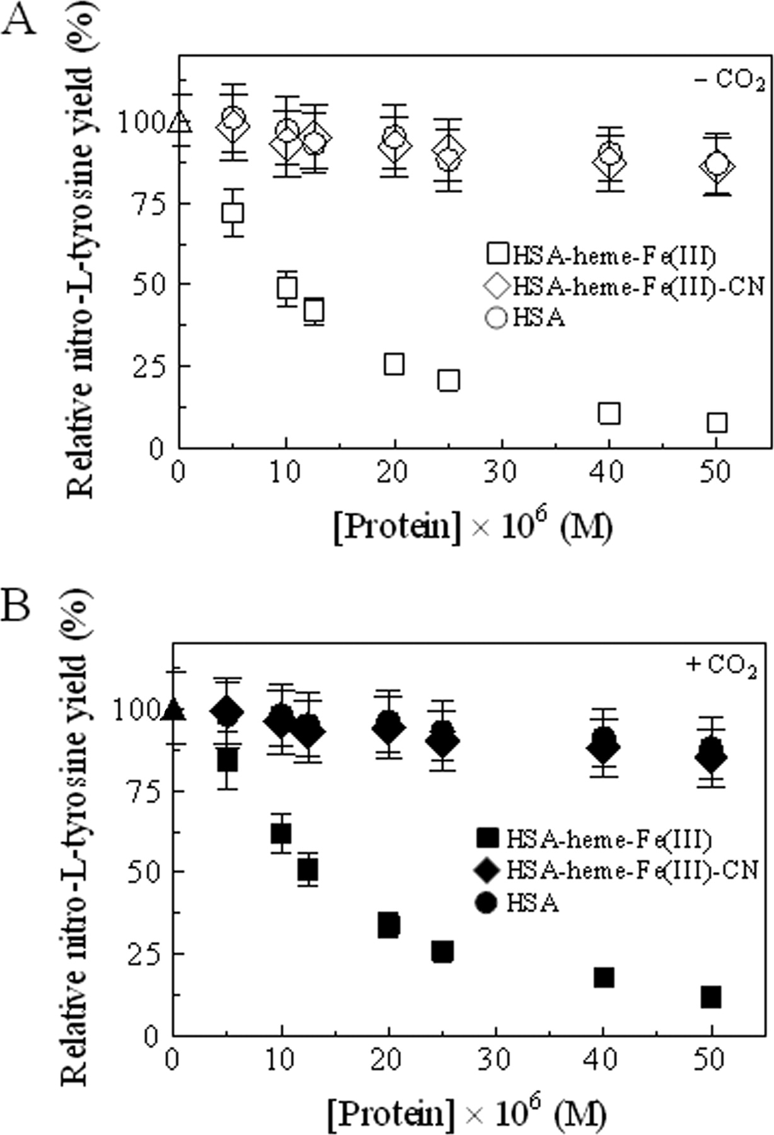  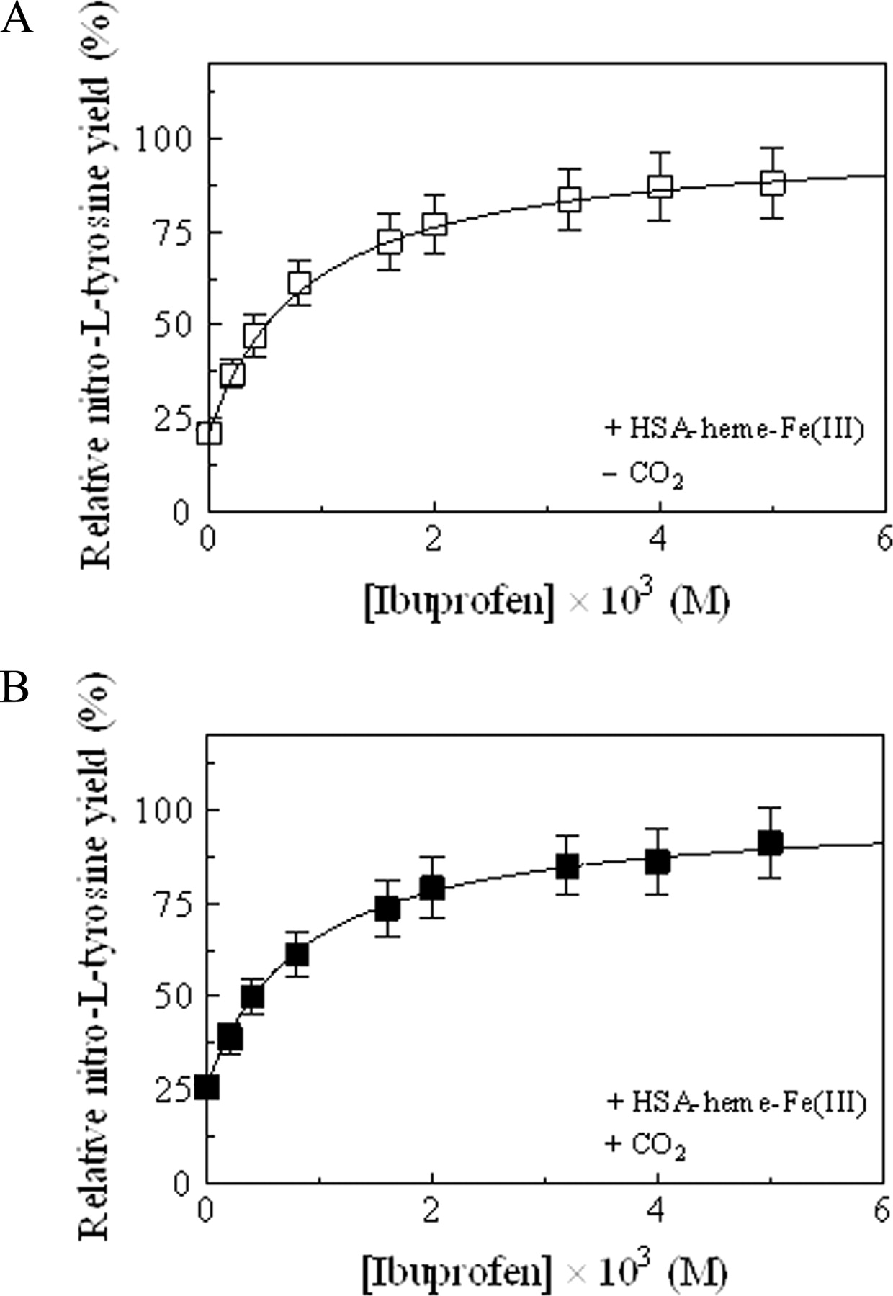  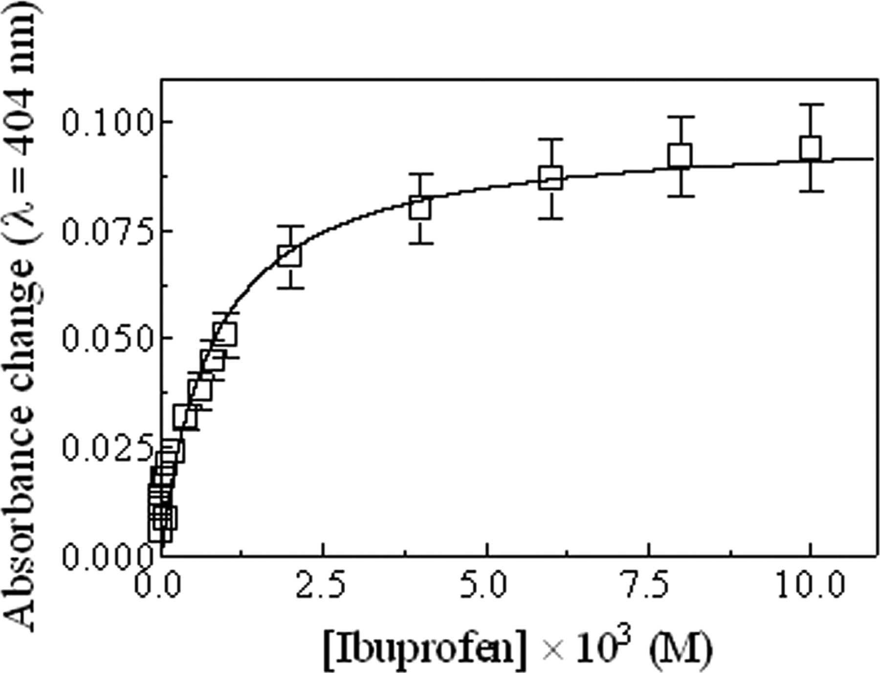 | concentration on the relative yield of nitro-L-tyrosine formed from the reaction of peroxynitrite with free L-tyrosine, at pH 7.2 and 22.0 °C, in the absence (A) and presence (B) of CO₂. The free L-tyrosine concentration was 1.0 × 10⁻⁴ M. The peroxynitrite and CO₂ concentration was 2.0 × 10⁻⁴ and 1.2 × 10⁻³ M, respectively. Relative yield (%) = (yield with added protein/yield with no protein) × 100. Where not shown, the S.D. value is smaller than thesymbol.  The ability of ibuprofen to impair allosterically HSA-heme-Fe(III)-mediated peroxynitrite isomerization prompted us to investigate the role of this drug in modulating peroxynitrite-based L-tyrosine nitration, in the absence and presence of CO₂. The relative yield of nitro-L-tyrosine increased upon increasing the ibuprofen concentration, at fixed HSA-heme-Fe(III), peroxynitrite, L-tyrosine, and CO₂ concentration (Fig. 7). The analysis of the data, according to Equation 7, allowed the determination of values of the dissociation equilibrium constant L in the absence and presence of CO₂ (8.7 × 10⁻⁴ and 8.4 × 10⁻⁴ M, respectively).  FIGURE 7. Effect of ibuprofen concentration on the relative yield of nitro-L-tyrosine formed from the reaction of peroxynitrite with free L-tyrosine, at pH 7.2 and 22.0 °C, in the presence of HSA-heme-Fe(III) and in the absence (A) and presence (B) of CO₂. The continuous lineswere calculated according toEquation 7 with the following parameters: L = 8.7 × 10⁻⁴ Mand r = 21.1% (A) and L = 8.4 × 10⁻⁴ M and r = 25.9% (B). The concentration of HSA-heme-Fe(III), peroxynitrite, free L-tyrosine, and CO₂ was 2.5 × 10⁻⁵, 2.0 × 10⁻³, 1.0 × 10⁻⁴, and 1.2 × 10⁻³ M, respectively. Relative yield (%) = (yield with added protein/yield with no protein) × 100. Where not shown, the S.D. value is smaller than thesymbol.  Spectrophotometric Evidence for Ibuprofen Binding to HSA-Heme-Fe(III)  To further support ibuprofen binding to HSA-heme-Fe(III), the value of the dissociation equilibrium constant for complex formation (L) has been determined spectrophotometrically (Fig. 8). The analysis of the data, according to Equation 6, allowed the determination of the dissociation equilibrium constant L (7.7 × 10⁻⁴M). The value of L obtained spectrophotometrically (7.7 × 10⁻⁴ M) (Fig. 8) is in excellent agreement with those obtained from the effect of ibuprofen concentration on (i) HSA-heme-Fe(III)-catalyzed isomerization of peroxynitrite in the absence and presence of CO₂ (L = 9.7 × 10⁻⁴ M) (Fig. 5C) and (ii) the relative nitro-L-tyrosine yield in the absence and presence of CO₂ (L = 8.7 × 10⁻⁴ and 8.4 × 10⁻⁴ M, respectively) (Fig. 7). Note that the heme-Fe(III)-ibuprofen complex, which could potentially interfere, only occurs at an ibuprofen concentration of ≥7.5 × 10⁻² (38).  FIGURE 8. Spectrophotometric titration of ibuprofen binding to HSA-heme-Fe(III), at pH 7.2 and 22.0 °C. The HSA-heme-Fe(III) concentration was 1.0 × 10⁻⁵M. The continuous line was calculated according toEquation 8 with L = 7.7 × 10⁻⁴M. Where not shown, the S.D. value is smaller than thesymbol.  DISCUSSION Ibuprofen, the prototype ligand of Sudlow's site II (1, 3, 26, 58), modulates allosterically peroxynitrite isomerization by HSA-heme-Fe(III) and therefore the peroxynitrite-mediated nitration of free L-tyrosine, highlighting the role of heterotropic ligands on the HSA reactivity (11, 13, 52, 81).  Peroxynitrite isomerization is facilitated by the HSA-heme-Fe(III)
species, whereas the HSA-heme-Fe(III)-CN derivative and the heme-free HSA are both non-reactive, clearly demonstrating that the efficiency of the isomerization process mirrors the heme-Fe(III) reactivity. As already reported for horse and sperm whale Mb and Human Hb (67, 70), peroxynitrous acid appears to be the species that preferentially reacts with HSA-heme-Fe(III). In addition, like horse heart Mb, sperm whale Mb, and Human Hb (67, 70), HSA-heme-Fe(III) protects free L-tyrosine from peroxynitrite-mediated nitration.
Allosteric inhibition of the HSA-heme-Fe(III)-mediated peroxynitrite isomerization by ibuprofen is related to drug-dependent structural changes occurring at the FA1 site (i.e. at the heme binding pocket). Indeed, UV-visible, resonance Raman, and electron paramagnetic resonance spectroscopies evidenced that the pentacoordinated heme-Fe(III) atom of HSA-heme-Fe(III), observed in the absence of ibuprofen, becomes hexacoordinated low spin upon ibuprofen binding (38). On the basis of the crystal structure of HSA-heme-Fe(III) (21), the His¹⁴⁶ residue was suggested as the putative ligand able to coordinate to the heme-Fe(III) atom in the sixth position upon ibuprofen binding (38). In contrast, in both ibuprofen-free pentacoordinated and ibuprofen-bound hexacoordinated HSA-heme-Fe(III), the Tyr¹⁶¹ residue coordinates to the heme-Fe(III) atom in the fifth position (38). Therefore, the presence of a strong ligand (either the His¹⁴⁶ residue or the exogenous cyanide ligand) at the sixth coordination position of the heme-Fe(III) atom inhibits peroxynitrite isomerization, thus rendering HSA-heme-Fe(III) non-reactive.
The identity of the ibuprofen binding pocket(s) (among the three possible ones, namely FA2, FA6, and Sudlow's site II) responsible for this allosteric effect is still unclear.
Structural and solution studies of ibuprofen binding to HSA have shown that the ibuprofen primary binding site (i.e. Sudlow's site II formed by FA3 and FA4 clefts) does not appear to be allosterically linked to the heme binding site (i.e. FA1) (30,37, 38, 55), ruling out the possibility that Sudlow's site II is responsible for the effect of ibuprofen on peroxynitrite isomerization by HSA-heme-Fe(III).
An additional candidate might be the ibuprofen secondary site FA6, which modulates negatively heme-Fe(III) binding to FA1 (12, 37) and the affinity of the secondary drug binding cleft FA2 (34, 37, 38, 81). The FA6 site (located within domain II at the interface between subdomains IIA and IIB) is in close structural and functional contact with Sudlow's site I (i.e. the Warfarin binding site), which is allosterically linked to the heme binding cleft (i.e. FA1) (12, 37). However, since the dissociation equilibrium constant for ibuprofen binding to the FA6 site has been reported to fall in the 4.0 × 10⁻⁷ to 1.3 × 10⁻⁵ M range (depending on the absence and presence of allosteric effector(s)) (55), we can also rule out that the effect of ibuprofen on peroxynitrite isomerization is related to drug binding to the FA6 site. Indeed, the average value of the dissociation equilibrium constant for ibuprofen binding to HSA-heme-Fe(III) here determined (L) from the dependence of either k_{on} or the relative yield of nitro-L-tyrosine or spectrophotometric changes in the Soret band on the ibuprofen concentration is at least 50-fold higher (8.8 × 10⁻⁴ M) (Figs. 6⇑–8).
As a whole, FA2, the only ligand binding site that provides contacts with different HSA subdomains (being located at the interface between subdomains IIA and IIB), could represent the ibuprofen secondary cleft functionally linked to the heme-Fe(III) atom reactivity (37). Thus, the average value of L (8.8 × 10⁻⁴ M) here determined (Figs. 6⇑–8) could reflect ibuprofen binding to the FA2 site of HSA-heme-Fe(III). Noticeably, this L value is grossly similar to that obtained from the ibuprofen-dependent resonance Raman spectroscopic changes of HSA-heme-Fe(III), reflecting hexacoordination of the heme-Fe(III) atom (L = 4.0 × 10⁻⁴ M) (38).
Peroxynitrite isomerization by heme-Fe(III) proteins (e.g. HSA-heme-Fe(III)) could represent a physiological detoxification mechanism, protecting cells from reactive nitrogen and oxygen species (78). Note that values of k_{on} for peroxynitrite isomerization by HSA-heme-Fe(III) are higher by about 1 order of magnitude than those reported for ferric horse heart Mb, sperm whale Mb, Human Hb, and heme-model compounds (67, 70, 82, 83) (supplemental Table S2). Moreover, peroxynitrite isomerization by HSA-heme-Fe(III) (supplemental TableS2) is faster than peroxynitrite scavenging by ferrous nitrosylated heme proteins, which appears to be strongly limited by (i) the dissociation of the transient heme-Fe(III)-NO and (ii) the reduction of the final heme-Fe(III) species to the heme-Fe(II) derivative (50). Remarkably, peroxynitrite isomerization by heme-Fe(III) proteins (e.g. HSA-heme-Fe(III)) does not require any redox cycle.
Due to the relevant physiological role of HSA in Human plasma, several in vivoimplications can be argued from the present results. Indeed, peroxynitrite isomerization by HSA-heme-Fe(III) could occur only in patients affected with a variety of severe hematologic diseases characterized by excessive intravascular hemolysis. Under these pathological conditions, the HSA-heme-Fe(III) plasmatic level increases from the physiological concentration (∼1 × 10⁻⁶ M) to
∼4 × 10⁻⁵M (59, 84), HSA acting as the main heme-Fe(III) plasma depot (84, 85). To mimic as much as possible this condition, the HSA-heme-Fe(III) concentration here used ranged from 5.0 × 10⁻⁶ to 5.0 × 10⁻⁵ M. The high heme plasma concentration is invariably associated with a reduction of hemopexin in patients affected by excessive intravascular hemolysis (59). Note that upon increasing heme plasma level, hemopexin, whose plasma concentration (∼1.5 × 10⁻⁵ M) (84, 85) is about 2 orders of magnitude lower than that of HSA (7.5 × 10⁻⁴ M) (3), undergoes heme saturation, highlighting the role of HSA as a heme scavenger (84, 85).
Although the in vivo concentration of peroxynitrite is openly debated, the level of peroxynitrite in the reperfused ischemic heart has been reported to be much higher than micromolar concentration, at least over brief period of time (86, 87), overlapping with the lowest peroxynitrite concentration here used (2.5 × 10⁻⁵ M).
Finally, considering the plasma level of ibuprofen (∼10⁻⁴ to 10⁻³ M) (88,–,90), the drug concentration here used ranged between 5.0 × 10⁻⁵ M and 1.0 × 10⁻² M. Accounting for the average L value (∼8.8 × 10⁻⁴ M) here determined and the plasma level of ibuprofen, the molar fraction of the drug-bound HSA-heme-Fe(III) could range between 10 and 50%.
CONCLUSIONS Data here reported highlight the role of drugs in modulating HSA functions. This is relevant for the potential role played by HSA-heme in the detoxification process, also taking into account that the HSA-heme-Fe(III) plasmatic concentration increases significantly under pathological conditions (11, 13, 52,59, 84). Therefore, the higher HSA-heme concentration and the higher efficiency of peroxynitrite isomerization altogether contribute to identify HSA-heme as a major detoxification element in the bloodstream. This aspect acquires an even higher value in consideration of the protective role, played by the peroxynitrite isomerization, on the nitration of aromatic residues (such as tyrosine), which represent a relevant post-translational protein modification process (91). Last, HSA, not only acting as a heme carrier but also displaying transient heme-based properties, represents a case for “chronosteric effects” (52), which opens the scenario toward the possibility of a time- and metabolite-dependent multiplicity of roles for HSA.

Acknowledgment We thank Dr. Elisabetta De Marinis for helpful discussions.

Footnotes↵* This work was supported in part by grants from the Ministry for Health of Italy (National Institute for Infectious Diseases I.R.C.C.S. “Lazzaro Spallanzani,” Roma, Italy, Ricerca Corrente 2008) (to P. A.) and the Italian Ministry of University and Research (COFIN 2007SFZXZ7002) (to M. C.).
↵ The on-line version of this article (available at http://www.jbc.org) contains supplemental Tables S1 and S2 and Figs. S1 and S2.
↵4 The recommended IUPAC nomenclature for peroxynitrite is oxoperoxonitrate(1-), and the recommended nomenclature for peroxynitrous acid is hydrogen oxoperoxonitrate. The term “peroxynitrite” is used here to refer generically to both ONOO⁻ and its conjugate acid ONOOH (67, 70, 72).
↵3 The abbreviations used are:HSA Human serum albumiņ;FA-fatty acid;Hb-hemoglobin;
HSA-heme-Human serum heme-albumin;HSA-heme-Fe(III)-CN-HSA-heme-Fe(III)-cyanide complex;
HSA-heme-Fe(II)-NO-ferrous nitrosylated HSA;HSA-heme-Fe(III)-ferric HSA-heme;Mb-myoglobin;
HPLC-high pressure liquid chromatography.
REFERENCES

1. Sudlow G., Birkett D. J., Wade D. N. (1975) Mol. Pharmacol. 11, 824–832 Abstract/FREE Full Text
2. Carter D. C., Ho J. X. (1994) Adv. Protein Chem. 45, 153–203 Medline Search Google Scholar
3. Peters T. Jr.. (1996) All about Albumin: Biochemistry, Genetics and Medical Applications, Academic Press, Inc., San Diego Search Google Scholar
4. Bertucci C., Domenici E. (2002) Curr. Med. Chem. 9, 1463–1481 Medline Search Google Scholar
5. Curry S. (2002) Vox Sang. 83, Suppl. 1, 315–319 Medline Search Google Scholar
6. Kragh-Hansen U., Chuang V. T., Otagiri M. (2002) Biol. Pharm. Bull. 25, 695–704 CrossRefMedline Search Google Scholar
7. Sakurai Y., Ma S. F., Watanabe H., Yamaotsu N., Hirono S., Kurono Y., Kragh-Hansen U., Otagiri M. (2004) Pharm. Res. 21, 285–292 CrossRefMedline Search Google Scholar
8. Sułkowska A., Bojko B., Równicka J., Sułkowski W. (2004) Biopolymers 74, 256–262 CrossRefMedline Search Google Scholar
9. Ascenzi P., Bocedi A., Bolli A., Fasano M., Notari S., Polticelli F. (2005) Biochem. Mol. Biol. Educ. 33, 169–176 CrossRefMedline Search Google Scholar
10. Bocedi A., Notari S., Menegatti E., Fanali G., Fasano M., Ascenzi P. (2005) FEBS J. 272, 6287–6296 CrossRefMedline Search Google Scholar
11. Fasano M., Curry S., Terreno E., Galliano M., Fanali G., Narciso P., Notari S., Ascenzi P. (2005) IUBMB Life 57, 787–796 Medline Search Google Scholar
12. GHuman J., Zunszain P. A., Petitpas I., Bhattacharya A. A., Otagiri M., Curry S. (2005) J. Mol. Biol. 353, 38–52 CrossRefMedline Search Google Scholar
13. Ascenzi P., Bocedi A., Notari S., Fanali G., Fesce R., Fasano M. (2006) Mini Rev. Med. Chem. 6, 483–489 CrossRefMedline Search Google Scholar
14. Zunszain P. A., GHuman J., McDonagh A. F., Curry S. (2008) J. Mol. Biol. 381, 394–406 CrossRefMedline Search Google Scholar
15. He X. M., Carter D. C. (1992) Nature 358, 209–215 CrossRefMedline Search Google Scholar
16. Curry S., Mandelkow H., Brick P., Franks N. (1998) Nat. Struct. Biol. 5, 827–835 CrossRefMedline Search Google Scholar
17. Sugio S., Kashima A., Mochizuki S., Noda M., Kobayashi K. (1999) Protein Eng. 12, 439–446 Abstract/FREE Full Text
18. Bhattacharya A. A., Curry S., Franks N. P. (2000) J. Biol. Chem. 275, 38731–38738 Abstract/FREE Full Text
19. Bhattacharya A. A., Grüne T., Curry S. (2000) J. Mol. Biol. 303, 721–732 CrossRefMedline Search Google Scholar
20. Petitpas I., Bhattacharya A. A., Twine S., East M., Curry S. (2001) J. Biol. Chem. 276, 22804–22809 Abstract/FREE Full Text
21. Wardell M., Wang Z., Ho J. X., Robert J., Ruker F., Ruble J., Carter D. C. (2002) Biochem. Biophys. Res. Commun. 291, 813–819 CrossRefMedline Search Google Scholar
22. Petitpas I., Petersen C. E., Ha C. E., Bhattacharya A. A., Zunszain P. A., GHuman J., Bhagavan N. V., Curry S. (2003) Proc. Natl. Acad. Sci. U.S.A. 100, 6440–6445 Abstract/FREE Full Text
23. Zunszain P. A., GHuman J., Komatsu T., Tsuchida E., Curry S. (2003) BMC Struct. Biol. 3, 6 CrossRefMedline Search Google Scholar
24. Simard J. R., Zunszain P. A., Hamilton J. A., Curry S. (2006) J. Mol. Biol. 361, 336–351 CrossRefMedline Search Google Scholar
25. Fasano M., Fanali G., Leboffe L., Ascenzi P. (2007) IUBMB Life 59, 436–440 CrossRefMedline Search Google Scholar
26. Sudlow G., Birkett D. J., Wade D. N. (1976) Mol. Pharmacol. 12, 1052–1061 Abstract/FREE Full Text
27. Diana F. J., Veronich K., Kapoor A. L. (1989) J. Pharm. Sci. 78, 195–199 CrossRefMedline Search Google Scholar
28. Yamasaki K., Maruyama T., Yoshimoto K., Tsutsumi Y., Narazaki R., Fukuhara A., Kragh-Hansen U., Otagiri M. (1999) Biochim. Biophys. Acta 1432, 313–323 CrossRefMedline Search Google Scholar
29. Dockal M., Chang M., Carter D. C., Rüker F. (2000) Protein Sci. 9, 1455–1465 Medline Search Google Scholar
30. Baroni S., Mattu M., Vannini A., Cipollone R., Aime S., Ascenzi P., Fasano M. (2001) Eur. J. Biochem. 268, 6214–6220 Medline Search Google Scholar
31. Simard J. R., Zunszain P. A., Ha C. E., Yang J. S., Bhagavan N. V., Petitpas I., Curry S., Hamilton J. A. (2005) Proc. Natl. Acad. Sci. U.S.A. 102, 17958–17963 Abstract/FREE Full Text
32. Spector A. A. (1975) J. Lipid Res. 16, 165–179 Abstract
33. Hamilton J. A., Cistola D. P., Morrisett J. D., Sparrow J. T., Small D. M. (1984) Proc. Natl. Acad. Sci. U.S.A. 81, 3718–3722 Abstract/FREE Full Text
34. Chuang V. T., Otagiri M. (2002) Pharm. Res. 19, 1458–1464 CrossRefMedline Search Google Scholar
35. Hamilton J. A. (2004) Prog. Lipid Res. 43, 177–199 CrossRefMedline Search Google Scholar
36. Fasano M., Baroni S., Vannini A., Ascenzi P., Aime S. (2001) J. Biol. Inorg. Chem. 6, 650–658 CrossRefMedline Search Google Scholar
37. Fanali G., Bocedi A., Ascenzi P., Fasano M. (2007) FEBS J. 274, 4491–4502 CrossRefMedline Search Google Scholar
38. Nicoletti F. P., Howes B. D., Fittipaldi M., Fanali G., Fasano M., Ascenzi P., Smulevich G. (2008) J. Am. Chem. Soc. 130, 11677–11688 CrossRefMedline Search Google Scholar
39. Dill K. A., Alonso D. O., Hutchinson K. (1989) Biochemistry 28, 5439–5449 CrossRefMedline Search Google Scholar
40. Carter D. C., Ho J. X., Rüker F. (9 7, 1999) United States Patent 5,948,609 Search Google Scholar
41. Komatsu T., Matsukawa Y., Tsuchida E. (2000) Bioconjug. Chem. 11, 772–776 CrossRefMedline Search Google Scholar
42. Mattu M., Vannin A., Coletta M., Fasano M., Ascenzi P. (2001) J. Inorg. Biochem. 84, 293–296 CrossRefMedline Search Google Scholar
43. Monzani E., Bonafè B., Fallarini A., Redaelli C., Casella L., Minchiotti L., Galliano M. (2001) Biochim. Biophys. Acta 1547, 302–312 CrossRefMedline Search Google Scholar
44. Fasano M., Mattu M., Coletta M., Ascenzi P. (2002) J. Inorg. Biochem. 91, 487–490 CrossRefMedline Search Google Scholar
45. Kamal J. K., Behere D. V. (2002) J. Biol. Inorg. Chem. 7, 273–283 CrossRefMedline Search Google Scholar
46. Monzani E., Curto M., Galliano M., Minchiotti L., Aime S., Baroni S., Fasano M., Amoresano A., Salzano A. M., Pucci P., Casella L. (2002) Biophys. J. 83, 2248–2258 CrossRefMedline Search Google Scholar
47. Komatsu T., Ohmichi N., Zunszain P. A., Curry S., Tsuchida E. (2004) J. Am. Chem. Soc. 126, 14304–14305 CrossRefMedline Search Google Scholar
48. Fanali G., Fesce R., Agrati C., Ascenzi P., Fasano M. (2005) FEBS J. 272, 4672–4683 CrossRefMedline Search Google Scholar
49. Komatsu T., Ohmichi N., Nakagawa A., Zunszain P. A., Curry S., Tsuchida E. (2005) J. Am. Chem. Soc. 127, 15933–15942 CrossRefMedline Search Google Scholar
50. Ascenzi P., Fasano M. (2007) Biochem. Biophys. Res. Commun. 353, 469–474 CrossRefMedline Search Google Scholar
51. Ascenzi P., Imperi F., Coletta M., Fasano M. (2008) Biochem. Biophys. Res. Commun. 369, 686–691 CrossRefMedline Search Google Scholar
52. Fasano M., Fanali G., Fesce R., Ascenzi P. (2008) Human Serum Haeme-albumin: An Allosteric “Chronosteric” Protein, pp. 121–131, Springer, Heidelberg Search Google Scholar
53. Baroni S., Pariani G., Fanali G., Longo D., Ascenzi P., Aime S., Fasano M. (2009) Biochem. Biophys. Res. Commun. 385, 385–389 CrossRefMedline Search Google Scholar
54. Fanali G., De Sanctis G., Gioia M., Coletta M., Ascenzi P., Fasano M. (2009) J. Biol. Inorg. Chem. 14, 209–217 CrossRefMedline Search Google Scholar
55. Fanali G., Pariani G., Ascenzi P., Fasano M. (2009) FEBS J. 276, 2241–2250 CrossRefMedline Search Google Scholar
56. Kragh-Hansen U., Watanabe H., Nakajou K., Iwao Y., Otagiri M. (2006) J. Mol. Biol. 363, 702–712 CrossRefMedline Search Google Scholar
57. Ascenzi P., Bocedi A., Notari S., Menegatti E., Fasano M. (2005) Biochem. Biophys. Res. Commun. 334, 481–486 CrossRefMedline Search Google Scholar
58. Bocedi A., Notaril S., Narciso P., Bolli A., Fasano M., Ascenzi P. (2004) IUBMB Life 56, 609–614 CrossRefMedline Search Google Scholar
59. Muller-Eberhard U., Javid J., Liem H. H., Hanstein A., Hanna M. (1968) Blood 32, 811–815 Abstract/FREE Full Text
60. Kharitonov V. G., Sharma V. S., Magde D., Koesling D. (1997) Biochemistry 36, 6814–6818 CrossRefMedline Search Google Scholar
61. Boffi A., Das T. K., della Longa S., Spagnuolo C., Rousseau D. L. (1999) Biophys. J. 77, 1143–1149 Medline Search Google Scholar
62. Cabrera-Crespo J., Gonçalves V. M., Martins E. A., Grellet S., Lopes A. P., Raw I. (2000) Biotechnol. Appl. Biochem. 31, 101–106 CrossRef Search Google Scholar
63. Fasano M., Bocedi A., Mattu M., Coletta M., Ascenzi P. (2004) J. Biol. Inorg. Chem. 9, 800–806 CrossRefMedline Search Google Scholar
64. Bohle D. S., Glassbrenner P. A., Hansert B. (1996) Methods Enzymol. 269, 302–311 CrossRefMedline Search Google Scholar
65. Koppenol W. H., Kissner R., Beckman J. S. (1996) Methods Enzymol. 269, 296–302 Medline Search Google Scholar
66. Herold S., Exner M., Boccini F. (2003) Chem. Res. Toxicol. 16, 390–402 CrossRefMedline Search Google Scholar
67. Herold S., Kalinga S., Matsui T., Watanabe Y. (2004) J. Am. Chem. Soc. 126, 6945–6955 CrossRefMedline Search Google Scholar
68. Ascenzi P., Visca P. (2008) Methods Enzymol. 436, 317–337 CrossRefMedline Search Google Scholar
69. Goldstein S., Merényi G. (2008) Methods Enzymol. 436, 49–61 CrossRefMedline Search Google Scholar
70. Herold S., Shivashankar K. (2003) Biochemistry 42, 14036–14046 CrossRefMedline Search Google Scholar
71. Antonini E., Brunori M. (1971) Hemoglobin and Myoglobin in Their Reactions with Ligands, North-Holland, Amsterdam Search Google Scholar
72. Pfeiffer S., Gorren A. C., Schmidt K., Werner E. R., Hansert B., Bohle D. S., Mayer B. (1997) J. Biol. Chem. 272, 3465–3470 Abstract/FREE Full Text
73. Herold S., Matsui T., Watanabe Y. (2001) J. Am. Chem. Soc. 123, 4085–4086 CrossRefMedline Search Google Scholar
74. Goldstein S., Lind J., Merényi G. (2005) Chem. Rev. 105, 2457–2470 CrossRefMedline Search Google Scholar
75. Miranda K. M., Espey M. G., Wink D. A. (2001) Nitric Oxide 5, 62–71 CrossRefMedline Search Google Scholar
76. Ascenzi P., Bocedi A., Bolognesi M., Fabozzi G., Milani M., Visca P. (2006) Biochem. Biophys. Res. Commun. 339, 450–456 CrossRefMedline Search Google Scholar
77. Squadrito G. L., Pryor W. A. (2002) Chem. Res. Toxicol. 15, 885–895 CrossRefMedline Search Google Scholar
78. Herold S., Fago A. (2005) Comp. Biochem. Physiol. A Mol. Integr. Physiol. 142, 124–129 CrossRefMedline Search Google Scholar
79. Ascenzi P., Bocedi A., Visca P., Minetti M., Clementi E. (2006) IUBMB Life 58, 611–613 CrossRefMedline Search Google Scholar
80. Kissner R., Koppenol W. H. (2002) J. Am. Chem. Soc. 124, 234–239 CrossRefMedline Search Google Scholar
81. Ascenzi P., di Masi A., De Sanctis G., Coletta M., Fasano M. (2009) Biochem. Biophys. Res. Commun. 387, 83–86 CrossRefMedline Search Google Scholar
82. Groves J. T. (1999) Curr. Opin. Chem. Biol. 3, 226–235 CrossRefMedline Search Google Scholar
83. Shimanovich R., Groves J. T. (2001) Arch. Biochem. Biophys. 387, 307–317 CrossRefMedline Search Google Scholar
84. Miller Y. I., Shaklai N. (1999) Biochim. Biophys. Acta 1454, 153–164 Medline Search Google Scholar
85. Ascenzi P., Bocedi A., Visca P., Altruda F., Tolosano E., Beringhelli T., Fasano M. (2005) IUBMB Life 57, 749–759 Medline Search Google Scholar
86. Schulz R., Dodge K. L., Lopaschuk G. D., Clanachan A. S. (1997) Am. J. Physiol. 272, H1212–H1219 Medline Search Google Scholar
87. Ma X. L., Gao F., Lopez B. L., Christopher T. A., Vinten-Johansen J. (2000) J. Pharmacol. Exp. Ther. 292, 912–920 Abstract/FREE Full Text
88. Regazzi B. M., Rondanelli R., Ciaroelli L., Bartoli A. L., Rampini A. (1986) Int. J. Clin. Pharmacol. Res. 6, 469–473 Medline Search Google Scholar
89. Martin W., Koselowske G., Töberich H., Kerkmann T., Mangold B., Augustin J. (1990) Biopharm. Drug Dispos. 11, 265–278 CrossRefMedline Search Google Scholar
90. Brown R. D., Wilson J. T., Kearns G. L., Eichler V. F., Johnson V. A., Bertrand K. M. (1992) J. Clin. Pharmacol. 32, 231–241 Abstract
91. Alvarez B., Radi R. (2003) Amino Acids 25, 295–311 CrossRefMedline Search Google Scholar

HETNAM MYR MYRISTIC ACID 1O9X
HETNAM HEM PROTOPORPHYRIN IX CONTAINING FE
HETSYN HEM [DIHYDROGEN 3,7,12,17-TETRAMETHYL-8,13-
HETSYN 2 HEM DIVINYL-2,18-PORPHINEDIPROPIONATO(2-)]IRON
FORMUL 2 MYR 6(C14 H28 O2)
FORMUL 8 HEM C34 H32 FE N4 O4
HELIX 1 1 SER A 5 GLY A 15 1 11 5- 15
HELIX 2 2 GLY A 15 LEU A 31 1 17 15 LEU A 31
HELIX 3 3 PRO A 35 ASP A 56 1 22 35 ASP A 56
HELIX 4 4 SER A 65 CYS A 75 1 11 65 CYS A 75
HELIX 5 5 THR A 79 TYR A 84 1 6 79 TYR A 84
HELIX 6 6 GLU A 86 CYS A 91 1 6 86 CYS A 91
HELIX 7 7 GLN A 94 HIS A 105 1 12 94 HIS A 105
HELIX 8 8 GLU A 119 ASN A 130 1 12 119 ASN A 130
HELIX 9 9 ASN A 130 HIS A 146 1 17 130 HIS A 146
HELIX 10 10 TYR A 150 CYS A 169 1 20 150 CYS A 169
HELIX 11 11 ASP A 173 PHE A 206 1 34 173 PHE A 206
HELIX 11 11 GLU A 208 PHE A 223 1 16 208 PHE A 223
HELIX 12 12 GLU A 227 GLY A 248 1 22 227 GLY A 248
HELIX 13 13 ASP A 249 ASN A 267 1 19 249 ASN A 267
HELIX 14 14 GLN A 268 ILE A 271 5 4 268 ILE A 271
HELIX 15 15 SER A 272 LYS A 276 5 5 272 LYS A 276
HELIX 16 16 GLU A 277 LYS A 281 5 5 277 LYS A 281
HELIX 17 17 PRO A 282 GLU A 292 1 11 282 GLU A 292
HELIX 18 18 SER A 304 VAL A 310 1 7 304 VAL A 310
HELIX 19 19 ASP A 314 ALA A 322 1 9 314 ALA A 322
HELIX 20 20 ALA A 322 ARG A 337 1 16 322 ARG A 337
HELIX 21 21 SER A 342 CYS A 361 1 20 342 CYS A 361
HELIX 22 22 ASP A 365 CYS A 369 5 5 365 CYS A 369
HELIX 23 23 LYS A 372 LEU A 398 1 27 372 LEU A 398
HELIX 24 24 GLY A 399 LYS A 413 1 15 399 LYS A 413
HELIX 25 25 SER A 419 LYS A 439 1 21 419 LYS A 439
HELIX 26 26 PRO A 441 ALA A 443 5 3 441 ALA A 443
HELIX 27 27 LYS A 444 THR A 467 1 24 444 THR A 467
HELIX 28 28 ARG A 472 GLU A 479 1 8 472 GLU A 479
HELIX 29 29 SER A 480 ALA A 490 1 11 480 ALA A 490
HELIX 30 30 ASN A 503 THR A 508 1 6 503 THR A 508
HELIX 31 31 SER A 517 LYS A 536 1 20 517 LYS A 536
HELIX 32 32 THR A 540 LYS A 560 1 21 540 LYS A 560
HELIX 33 33 GLU A 565 ALA A 581 1 17 565 ALA A 581
SSBOND 1 CYS A 53 CYS A 62 1555 1555 2.02
SSBOND 2 CYS A 75 CYS A 91 1555 1555 2.03
SSBOND 3 CYS A 90 CYS A 101 1555 1555 2.03
SSBOND 4 CYS A 124 CYS A 169 1555 1555 2.04
SSBOND 5 CYS A 168 CYS A 177 1555 1555 2.04
SSBOND 6 CYS A 200 CYS A 246 1555 1555 2.03
SSBOND 7 CYS A 245 CYS A 253 1555 1555 2.08
SSBOND 8 CYS A 265 CYS A 279 1555 1555 2.03
SSBOND 9 CYS A 278 CYS A 289 1555 1555 2.02
SSBOND 10 CYS A 316 CYS A 361 1555 1555 2.03
SSBOND 11 CYS A 360 CYS A 369 1555 1555 2.03
SSBOND 12 CYS A 392 CYS A 438 1555 1555 2.04
SSBOND 13 CYS A 437 CYS A 448 1555 1555 2.03
SSBOND 14 CYS A 461 CYS A 477 1555 1555 2.03
SSBOND 15 CYS A 476 CYS A 487 1555 1555 2.04
SSBOND 16 CYS A 514 CYS A 559 1555 1555 2.03
SSBOND 17 CYS A 558 CYS A 567 1555 1555 2.03
LINK FE HEM A2001 OH TYR A 161 1555 1555 2.78
SITE 1 AC1 4 TYR A 150 ALA A 254 ARG A 257 SER A 287
SITE 1 AC2 4 SER A 342 ILE A 388 LEU A 453 ARG A 485
SITE 1 AC3 5 TYR A 411 VAL A 415 LEU A 460 PHE A 488
SITE 2 AC3 5 SER A 489
SITE 1 AC4 4 TYR A 401 LYS A 525 MET A 548 PHE A 551
SITE 1 AC5 3 ARG A 209 LYS A 212 LYS A 351
SITE 1 AC6 6 LEU A 219 ARG A 222 LEU A 238 VAL A 241
SITE 2 AC6 6 HIS A 242 ARG A 257
SITE 1 AC7 12 ARG A 114 VAL A 116 MET A 123 TYR A 138
SITE 2 AC7 12 LEU A 139 ILE A 142 HIS A 146 PHE A 149
SITE 3 AC7 12 LEU A 154 ALA A 158 TYR A 161 LYS A 190

HETNAM IBP IBUPROFEN
HETSYN IBP 2-(4-ISOBUTYLPHENYL)PROPIONIC ACID
FORMUL 3 IBP 4(C13 H18 O2)
2BXG (12); ibuprofen,
HELIX 1 1 SER A 5 LEU A 31 1 27 5 LEU A 31
HELIX 2 2 PRO A 35 ASP A 56 1 22 35 ASP A 56
HELIX 3 3 SER A 65 CYS A 75 1 11 65 CYS A 75
HELIX 4 4 LEU A 80 GLY A 85 1 6 80 GLY A 85
HELIX 5 5 GLU A 86 ALA A 92 1 7 86 ALA A 92
HELIX 6 6 GLN A 94 HIS A 105 1 12 94 HIS A 105
HELIX 7 7 GLU A 119 ASN A 130 1 12 119 ASN A 130
HELIX 8 8 ASN A 130 HIS A 146 1 17 130 HIS A 146
HELIX 9 9 TYR A 150 CYS A 169 1 20 150 CYS A 169
HELIX 10 10 ASP A 173 GLY A 207 1 51 173 GLY A 207
HELIX 10 10 GLU A 208 PHE A 223 1 51 208 PHE A 223
HELIX 11 11 GLU A 227 HIS A 247 1 21 227 HIS A 247
HELIX 12 12 ASP A 249 ASN A 267 1 19 249 ASN A 267
HELIX 13 13 ASN A 267 SER A 272 1 6 267 SER A 272
HELIX 14 14 GLU A 277 LYS A 281 5 5 277 LYS A 281
HELIX 15 15 PRO A 282 GLU A 292 1 11 282 GLU A 292
HELIX 16 16 LEU A 305 VAL A 310 1 6 305 VAL A 310
HELIX 17 17 ASP A 314 ALA A 322 1 9 314 ALA A 322
HELIX 18 18 ALA A 322 ARG A 337 1 16 322 ARG A 337
HELIX 19 19 SER A 342 CYS A 361 1 20 342 CYS A 361
HELIX 20 20 ASP A 365 TYR A 370 1 6 365 TYR A 370
HELIX 21 21 VAL A 373 VAL A 415 1 43 373 VAL A 415
HELIX 22 22 SER A 419 CYS A 438 1 20 419 CYS A 438
HELIX 23 23 PRO A 441 THR A 467 1 27 441 THR A 467
HELIX 24 24 SER A 470 GLU A 479 1 10 470 GLU A 479
HELIX 25 25 ASN A 483 LEU A 491 1 9 483 LEU A 491
HELIX 26 26 ASN A 503 THR A 508 5 6 503 THR A 508
HELIX 27 27 HIS A 510 CYS A 514 5 5 510 CYS A 514
HELIX 28 28 SER A 517 LYS A 536 1 20 517 LYS A 536
HELIX 29 29 GLU A 542 ALA A 561 1 20 542 ALA A 561
HELIX 30 30 ASP A 563 GLU A 565 5 3 563 GLU A 565
HELIX 31 31 THR A 566 ALA A 582 1 17 566 ALA A 582

SSBOND 1 CYS A 53 CYS A 62 1555 1555 2.02
SSBOND 2 CYS A 75 CYS A 91 1555 1555 2.03
SSBOND 3 CYS A 90 CYS A 101 1555 1555 2.03
SSBOND 4 CYS A 124 CYS A 169 1555 1555 2.04
SSBOND 5 CYS A 168 CYS A 177 1555 1555 2.03
SSBOND 6 CYS A 200 CYS A 246 1555 1555 2.03
SSBOND 7 CYS A 245 CYS A 253 1555 1555 2.03
SSBOND 8 CYS A 265 CYS A 279 1555 1555 2.03
SSBOND 9 CYS A 278 CYS A 289 1555 1555 2.03
SSBOND 10 CYS A 316 CYS A 361 1555 1555 2.02
SSBOND 11 CYS A 360 CYS A 369 1555 1555 2.03
SSBOND 12 CYS A 392 CYS A 438 1555 1555 2.03
SSBOND 13 CYS A 437 CYS A 448 1555 1555 2.03
SSBOND 14 CYS A 461 CYS A 477 1555 1555 2.02
SSBOND 15 CYS A 476 CYS A 487 1555 1555 2.03
SSBOND 16 CYS A 514 CYS A 559 1555 1555 2.04
SSBOND 17 CYS A 558 CYS A 567 1555 1555 2.04

HETNAM MYR MYRISTIC ACID 1H9Z(20)MYR,warfarin
HETNAM RWF R-WARFARIN
HETSYN RWF 4-HYDROXY-3-[(1R)-3-OXO-1-PHENYLBUTYL]-2H-
HETSYN 2 RWF CHROMEN-2-ONE
FORMUL 2 MYR 6(C14 H28 O2)
FORMUL 3 RWF C19 H16 O4
FORMUL 4 HOH *28(H2 O)
HELIX 1 1 SER A 5 ASP A 13 1 9 5 ASP A 13
HELIX 2 2 GLY A 15 LEU A 31 1 17 15 LEU A 31
HELIX 3 3 PRO A 35 ASP A 56 1 22 35 ASP A 56
HELIX 4 4 SER A 65 CYS A 75 1 11 65 CYS A 75
HELIX 5 5 THR A 79 GLY A 85 1 7 79 GLY A 85
HELIX 6 6 GLU A 86 LYS A 93 5 8 86 LYS A 93
HELIX 7 7 GLN A 94 HIS A 105 1 12 94 HIS A 105
HELIX 8 8 GLU A 119 ASN A 130 1 12 119 ASN A 130
HELIX 9 9 ASN A 130 HIS A 146 1 17 130 HIS A 146
HELIX 10 10 TYR A 150 CYS A 169 1 20 150 CYS A 169
HELIX 11 11 ASP A 173 PHE A 206 1 34 173 PHE A 206
HELIX 12 12 PHE A 206 PHE A 223 1 18 206 PHE A 223
HELIX 13 13 GLU A 227 GLY A 248 1 22 227 GLY A 248
HELIX 14 14 ASP A 249 ASN A 267 1 19 249 ASN A 267
HELIX 15 15 GLN A 268 ILE A 271 5 4 268 ILE A 271
HELIX 16 16 SER A 272 LYS A 274 5 3 272 LYS A 274
HELIX 17 17 LEU A 275 LYS A 281 1 7 275 LYS A 281
HELIX 18 18 PRO A 282 ALA A 291 1 10 282 ALA A 291
HELIX 19 19 LEU A 305 VAL A 310 1 6 305 VAL A 310
HELIX 20 20 ASP A 314 ALA A 322 1 9 314 ALA A 322
HELIX 21 21 ALA A 322 ARG A 336 1 15 322 ARG A 336
HELIX 22 22 SER A 342 CYS A 361 1 20 342 CYS A 361
HELIX 23 23 ASP A 365 TYR A 370 1 6 365 TYR A 370
HELIX 24 24 VAL A 373 LEU A 398 1 26 373 LEU A 398
HELIX 25 25 GLY A 399 VAL A 415 1 17 399 VAL A 415
HELIX 26 26 SER A 419 CYS A 438 1 20 419 CYS A 438
HELIX 27 27 PRO A 441 ALA A 443 5 3 441 ALA A 443
HELIX 28 28 LYS A 444 THR A 467 1 24 444 THR A 467
HELIX 29 29 SER A 470 GLU A 479 1 10 470 GLU A 479
HELIX 30 30 ASN A 483 ALA A 490 1 8 483 ALA A 490
HELIX 31 31 ALA A 504 THR A 508 5 5 504 THR A 508
HELIX 32 32 HIS A 510 CYS A 514 5 5 510 CYS A 514
HELIX 33 33 SER A 517 LYS A 536 1 20 517 LYS A 536
HELIX 34 34 THR A 540 CYS A 559 1 20 540 CYS A 559
HELIX 35 35 ASP A 563 LEU A 583 1 21 563 LEU A 583

SSBOND 1 CYS A 53 CYS A 62 1555 1555 2.04
SSBOND 2 CYS A 75 CYS A 91 1555 1555 2.02
SSBOND 3 CYS A 90 CYS A 101 1555 1555 2.02
SSBOND 4 CYS A 124 CYS A 169 1555 1555 2.04
SSBOND 5 CYS A 168 CYS A 177 1555 1555 2.02
SSBOND 6 CYS A 200 CYS A 246 1555 1555 2.03
SSBOND 7 CYS A 245 CYS A 253 1555 1555 2.02
SSBOND 8 CYS A 265 CYS A 279 1555 1555 2.03
SSBOND 9 CYS A 278 CYS A 289 1555 1555 2.03
SSBOND 10 CYS A 316 CYS A 361 1555 1555 2.03
SSBOND 11 CYS A 360 CYS A 369 1555 1555 2.04
SSBOND 12 CYS A 392 CYS A 438 1555 1555 2.03
SSBOND 13 CYS A 437 CYS A 448 1555 1555 2.02
SSBOND 14 CYS A 461 CYS A 477 1555 1555 2.02
SSBOND 15 CYS A 476 CYS A 487 1555 1555 2.04
SSBOND 16 CYS A 514 CYS A 559 1555 1555 2.03
SSBOND 17 CYS A 558 CYS A 567 1555 1555 2.03

SITE 1 AC1 7 ARG A 117 MET A 123 TYR A 138 ALA A 158
SITE 2 AC1 7 TYR A 161 PHE A 165 HOH A2008
SITE 1 AC2 8 LEU A 66 TYR A 150 LEU A 251 ALA A 254
SITE 2 AC2 8 ARG A 257 SER A 287 HOH A2017 HOH A2027
SITE 1 AC3 6 SER A 342 ARG A 348 ILE A 388 GLY A 434
SITE 2 AC3 6 CYS A 438 ARG A 485
SITE 1 AC4 8 TYR A 411 VAL A 415 VAL A 418 LEU A 423
SITE 2 AC4 8 VAL A 426 LEU A 457 LEU A 460 SER A 489
SITE 1 AC5 5 TYR A 401 LYS A 525 ALA A 528 PHE A 551
SITE 2 AC5 5 SER A 579
SITE 1 AC6 2 ARG A 209 ASP A 324
SITE 1 AC7 8 TRP A 214 ALA A 215 ARG A 222 LEU A 238
SITE 2 AC7 8 HIS A 242 LEU A 260 ALA A 291 HOH A2028

