2006.Illimoise University
Physics, Computer Science, and Biophysics at University of Illinois
Peter Agre discovered the first aquaporin in 1992 in red blood cells and was awarded the 2003 Nobel Prize. Since then, 13 variants of aquaporin have been found in animals and humans and 35 in plants. There are thousands of these aquaporins in every cell membrane. Aquaporins contain a conduit that is so tiny that only a single water molecule at a time can pass through it. But this traffic can be lively indeed. In one second, several billion water molecules can get through. The direction of this water flow is contingent on the osmotic pressure. The water moves in a direction away from a low and toward a high concentration of salt and nutritional substances. But the conduit isn’t always open. The Lund scientists have found out how it opens and closes. This was done in collaboration with a team at Chalmers University of Technology in Göteborg, Sweden, under the direction of Richard Neutze, and with Emad Tajkhorshid at the University of Illinois 2005.

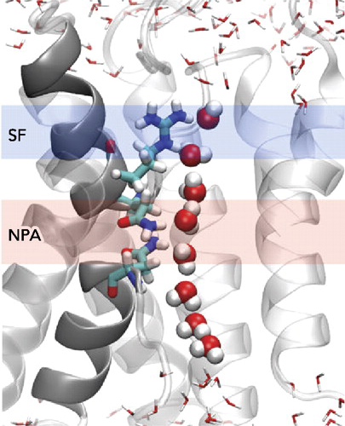 | Mid-Stream Flip-Flop  This closeup snapshot  shows the single-file 9  line of water 8 molecules H₂O  Hydrgen up   H-O-H  H-O-H  H-O-H  H-O-H  H-O-H  H-O-H  H-O-H  H-O-H  Hydrgen down 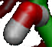  as they progress through  the aquaporin channel.  Because the water flips  at the mid-point of the channel,  protons H⁺ can’t pass through.

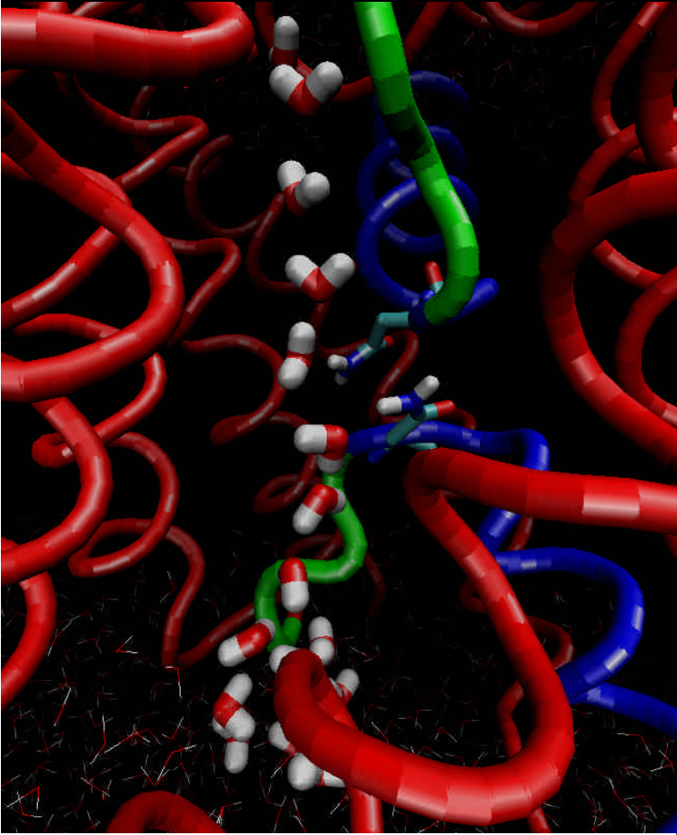
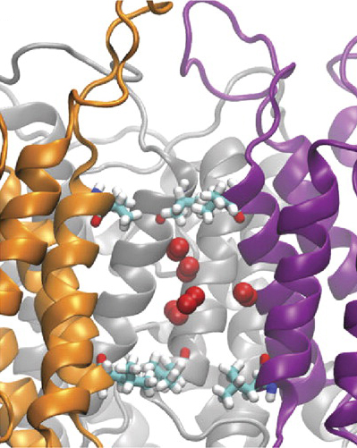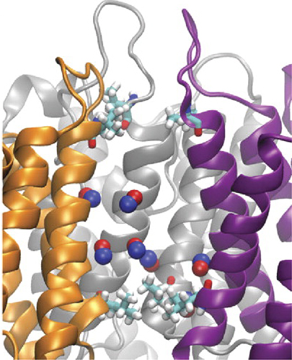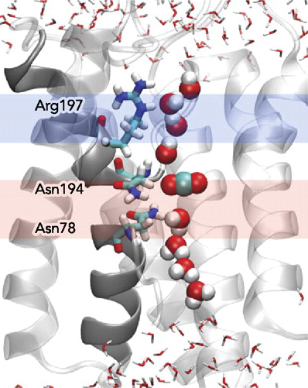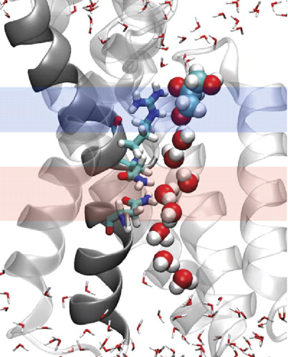
O₂ CO₂ NO glycerol HOH₂C-HCOH-CH₂OH
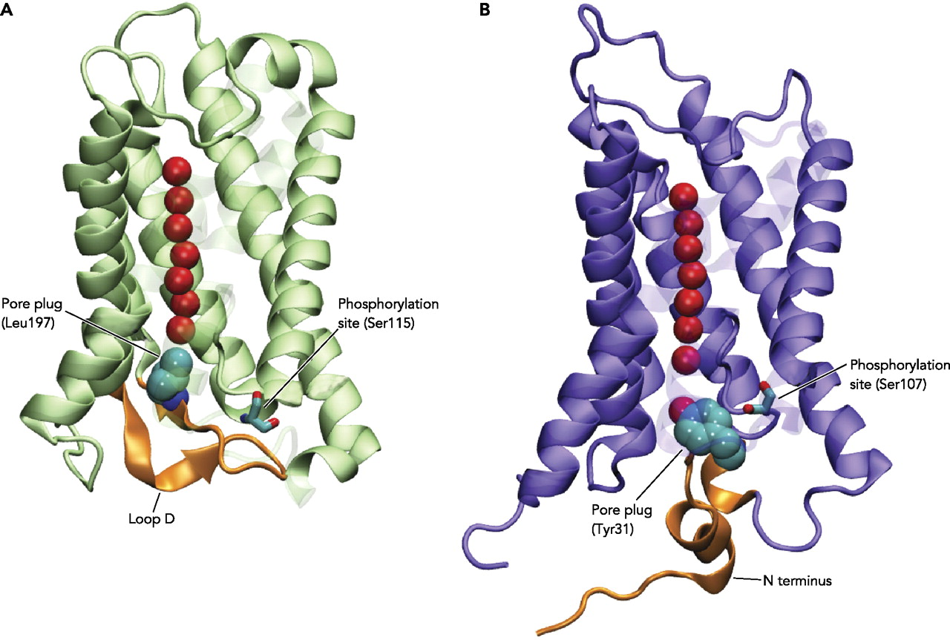 | Pore Plug amino acid residues  Tyr31 on N-terminus and  Leu197 on loop D  Phosphorilation sites  Ser115 and Ser107

