PART 3.
COLLIGATIVE PROPERTIES OF SOLUTIONS

These properties of solutions, that depend only on the concentration of solute particles are called colligative properties.
Colligative properties of solutions don’t depend on solute substance Thus, any colligative property has the same value, for instance, for sugar, alcohol, NaCl or H2SO4 solutions, if the concentration of solute particles is the same. There is also no difference, if the solute particle is a molecule or an ion - it will give the same increment into the intensity of any colligative property.
To the colligative properties belong:
1) solvent’s vapor pressure above solution,
2) freezing temperature depression of solution,
3) boiling temperature depression of solution
4) (partly) osmotic pressure of solution.
Prior to discussion of colligative properties themselves, we have to find the interrelation between the total concentration of solute and the concentration of solute particles.
I. ISOTONIC COEFFICIENT
Isotonic coefficient (or Vant Hoff’s coefficient) is the proportionality coefficient between the total concentration of a solute and concentration of solute particles.
Particle concentration can be calculated from solute concentration as :
(3.1)
where:
i is the isotonic coefficient
Cparticles is the concentration of solute particles
Ctotal is the total concentration of solute
In other words, i shows, how many times particle concentration exceeds solute concentration:
In solutions of non-electrolytes, where solute doesn’t dissociate into ions, the smallest particle is molecule, therefore particle concentration is equal to solute concentration and i = 1.
In solutions of electrolytes molecules of solute dissociate into ions and dissociation is characterized by dissociation degree α:
,
where:
ndiss. and Cdiss. are number and concentration of dissociated molecules respectively,
ntotal and Ctotal are total number and total concentration of molecules respectively.

Dissociation degree α can be expressed either as usual decimal number or in procents. For example both expressions
α = 0.04 and α = 4%
mean that 4 molecules out of every 100 molecules are disociated. Nevertheless, if dissociation degree has to be used in further calculations, it has to be transformed into a decimal number
Using the above expression of α the concentration of dissociated molecules is found as the total concentration of solute, multiplied by dissociation degree α:
Cdiss = α Ctotal,
Our task is to express the isotonic coefficient i through dissociation degree α and the total concentration of solute. Let us first note, that the concentration of particles includes both the concentration of non-dissociated molecules and the concentration of ions:
Cparticles = Cnondiss.mol. + Cions
The concentration of nondissociated molecules can be expressed as:
Cnondiss = Ctotal - Cdiss = Ctotal - α Ctotal
To express the concentration of ions, let us first invent a parameter m, which is the number of ions, formed at dissociation of one solute molecule:
For example, for NaCl m=2 (one Na+ and one Cl- ion are formed at dissociation of one molecule), for K3PO4 m = 4, as three K+ ions and one PO4 ion are formed. As m ions are created at dissociation of one molecule, concentration of ions is m times greater, than concentration of dissociated molecules:
Cions = m Cdiss = α m Ctotal
Inserting the meaning of Cnondiss and Cions into (3.1), we have:
(3.2.)
From (3.2.) one can see, that for a nonelectrolyte i = 1, because it doesn’t dissociate into ions and therefore its α = 0. As soon as α > 0 (the solute is an electrolyte), i is greater than 1 and particle concentration exceeds solute concentration.
II. SOLVENTS' VAPOR PRESSURE
Solvents' vapor pressure is the first of the colligative properties of solutions, that we have to deal with. Let us compare the vapor pressures of pure solvent and solution. When pure solvent is in contact with gas phase, two reverse processes proceed at the same time:
1) solvent molecules leave the surface of liquid phase (evaporate) and transfer into gas phase,
2) as soon as there are solvent molecules in the gas phase, they start to condense - to return back into liquid phase.
After some time an equilibrium is reached, at which the rates of evaporation and condensation are equal and a certain value of solvent’s vapor pressure p° is reached, see fig.3.1a.
Now let us consider a solution of a nonfugitive solute instead of pure solvent, see fig.3.1b. The same two processes occur, but another equilibrium is reached. At this case the upper layer of liquid phase doesn’t consist only of solvent molecules (empty dots in fig.3.1), but solute particles (filled dots) are present, too. For this reason the number of solvent molecules in the upper layer of liquid is smaller, than for pure solvent, the rate of evaporation is smaller, too and the equilibrium will be therefore reached at a smaller vapor pressure. Thus, the vapor pressure P above solution is smaller, than vapor pressure Po above pure solvent
Because of the reasons mentioned above the vapor pressure of solvent must be different at different concentrations of solute particles - the greater is the concentration of solute particles, the less water molecules remain in the surface layer of solution and, hence, the smaller becomes vapor pressure
of the solvent H₂O.
p° > p_{H2O}  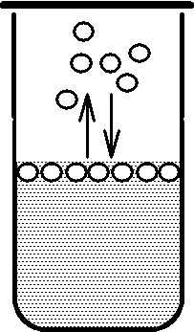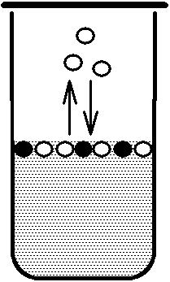  H₂O N_{x} solute | Fig.3.1. Solvents' H₂O vapor pressure  above pure solvent H₂O (a) and  solution N_{x} solute (b).

The dependence of solvents' vapor pressure on the concentration of solute is decsribed quantitatively by Raoults' I law, which states, that:
Relative depression of solvent’s vapor pressure is equal to molar fraction of solute particles.
Mathematical form of this law is:
, where:
(P° - P)/P° is called the relative depression of vapor pressure,
Nx = nx /(nx +no) is the molar fraction of solute,
nx and no are numbers of moles of solute particles and solvent respectively.
If the solute is a non-electrolyte,
Nx = Nsolute,
as the solute is present only in molecular form, for electrolytes
Nx =i.Nsolute,
because the number of particles is i times greater than number of molecules. Looking at fig.3.1, one can also understand, that, the greater is concentration of solute, the lower will be solvent’s vapor pressure.
III.WATER PHASE DIAGRAM
Prior to discussion of next two colligative properties - boiling point raise and freezing point depression of solution, compared to pure water, we have to understand the water phase diagram, see fig.3.2. In this diagram pressure is plotted versus temperature. Three curves AO, OB and OC divide the diagram into three regions a, b and c. Considering region a, where pressures are high, but temperatures are low, it is likely, that water is solid. In region C, where pressures are low, water is gas in wide temperature interval. Region b at medium temperatures and high pressures corresponds to liquid water.
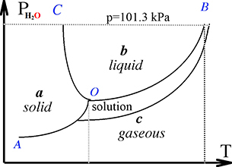 | Fig.3.2.Water phase diagram. Curve AO separates gaseous phase water vapor and solid phase’s ice. This curve expresses the equilibrium between solid water (an ice) and gaseous water vapor c. Each point of curve A shows the vapor pressure above ice at a given temperature. Curve OB is the equilibrium curve
0º C 100º C between liquid water and water vapor and each point on this curve shows the vapor pressure of liquid water at a given temperature. Point O, which is the intersection point of all three curves, is the point, at which vapor pressure above solid and liquid water is equal. It is the melting point of ice or freezing point of liquid water and the freezing temperature of liquid water can be found as abscissa of this point 0º C.
Evaporation point of water at temperature 100º C when water vapor pressure p_{H2O} is equal to atmosphere pressure p= 101,3 kPa starts the boiling the water if heat supply continues.
IV. FREEZING POINT DEPRESSION
As it was shown in the previous chapter, freezing point of liquid water is the intersection point of vapor pressure curves above liquid water and ice. In order to see difference between freezing points of pure solvent (water) and solution, one has to show vapor pressure curves of pure solvent (water) and solution in the same diagram. As it is clear from previous considerations (see fig.3.1 and comments to it),vapor pressure of solution is lower, than vapor pressure of pure solvent. As this is true at any temperature, all the vapor pressure curve for solution lies lower than for pure water, see fig.3.3. Fig.3.3. Freezing point depression.
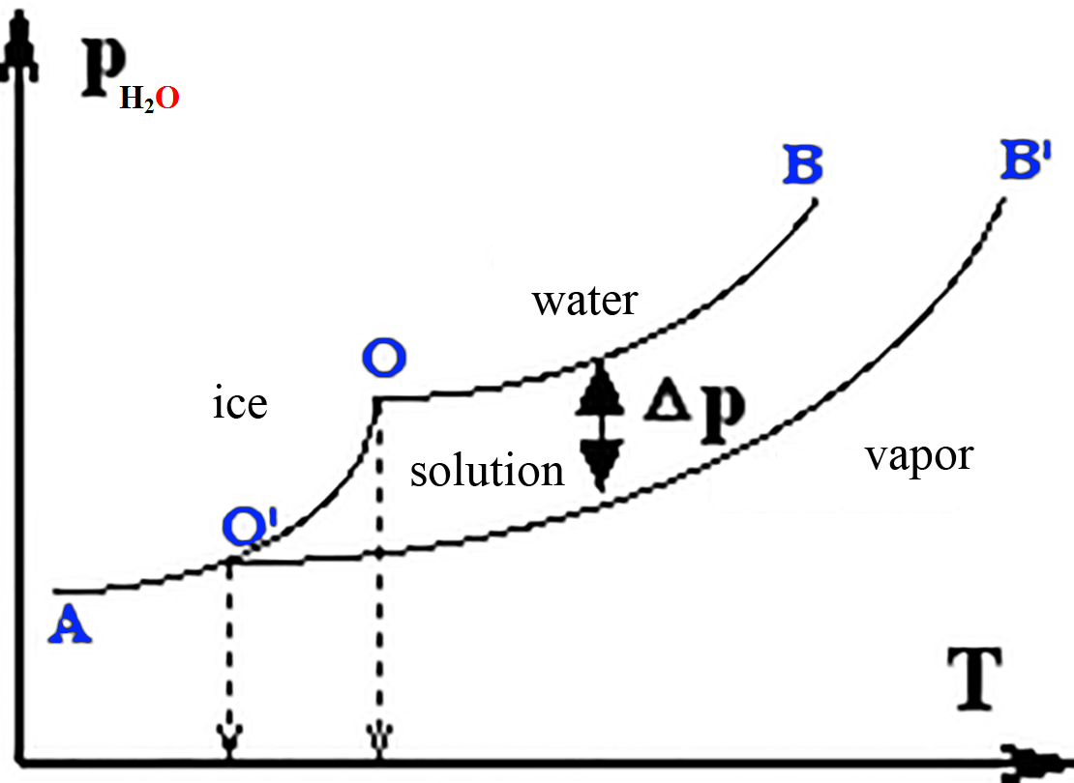 | As the result of this, the intersection point between vapor pressure of solution and vapor pressure of ice (the freezing point of solution) lies at lower temperature, than for pure water - the freezing point is shifted towards lower temperatures (depressed).
t_{fr} t _{fr}=0° C where ∆t _{fr}=0°-t_{fr} is the difference between freezing
temperatures of water and solution,
C_{m} is molality of solute (number of solute moles in 1000 grams solution),
Freezing (cryos greekish) K_{cr} =1.86 is the cryoscopy constant of the water.
Cryoscopy constant of water 1.86 shows the freezing point depression in a 1 molal non-electrolyte solution (where i = 1) freezes at temperature –1,86° C less zero 0° C.
Cryoscopy constant is a constant value for water and it doesn’t depend on the properties of solute, because the freezing point depression as a colligative property is affected by concentration of particles, but not by their nature. In fact, Roul’s laws are strongly valid only for diluted solutions, while it is possible to ignore the interaction of solute particles. For this reason one can use molarity instead of molality for approximate calculations - C_{m}≈ C_{M} in diluted solutions.
V.BOILING POINT RAISE
Boiling point of solution, as well as the freezing point of solution, differs from the boiling point of pure solvent. To understand this, let us think a little about the boiling process.
Boiling is the evaporation of solvent from all the liquid phase - bubbles of gaseous solvent are formed in all the volume of liquid phase and come out of it.
When a liquid is heated, at low temperatures the evaporation of solvent occurs only from the surface of liquid. Only at a certain temperature (100°C for water) bubble formation in volume of liquid phase begins.
The factor, that doesn’t allow the bubble formation at lower temperatures, is the atmospheric pressure - while vapor pressure inside bubble is smaller, than atmospheric pressure, the bubble is suppressed and cannot leave volume of liquid phase.
Thus, boiling starts at a temperature, at which vapor pressure of water reaches atmospheric pressure, therefore the boiling point of liquid is found as an intersection point between vapor pressure curve of liquid phase and the atmospheric pressure level, see fig.3.4. The intersection point of pure water vapor pressure curve OB and normal atmospheric pressure level corresponds to temperature 100°C.
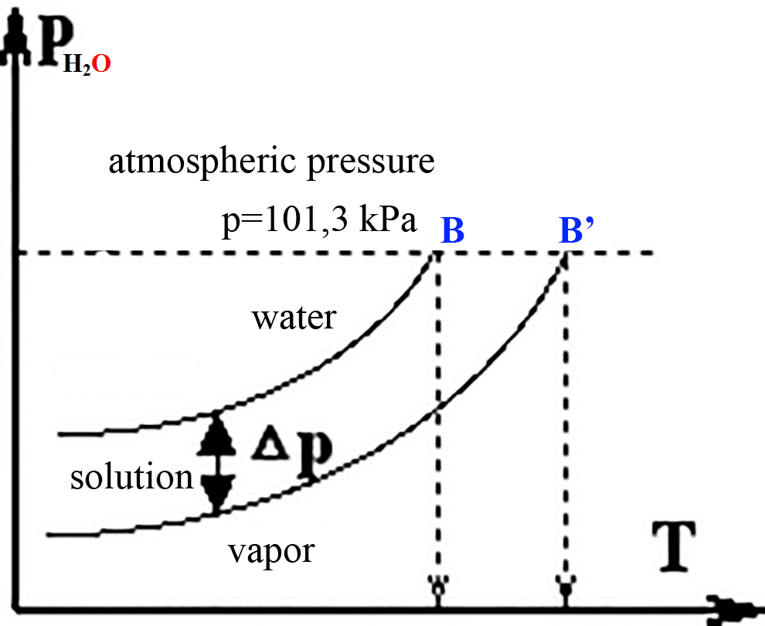 | Fig.3.4. Boiling point raise. As the vapor pressure curve of solution O’B’ lies lower, than the vapor pressure curve of pure water, its intersection with atmospheric pressure level is situated at lower temperature, than for solutio. In other words, as the vapor pressure of solution at any temperature is lower than the one of pure water, at 100°C
t_{b}=100° C t_{b}=100° C +∆t_{boiling} │ vapor pressure above solution
has not yet reached level of atmospheric pressure and the solution has to be heated up to a higher temperature to start boiling.
The boiling point raise (the difference between the boiling points of solution and pure water) is linked to solute concentration by an equation, similar to the one for freezing point: ∆t_{boiling}= i K_{eb} C_{m}, (3.5)
where K_{eb} = 0.52 ebullioscopy (ebulios means boiling in Greek) constant of water, which shows the value of boiling point
t_{b}=100.52° C raise to value of temperature in 1 molal solution of any non-electrolyte in water.

CRYOSCOPIC osmo molar values determination and APLICATIONS

1.Cryoscopy and ebullioscopy is used for quantitative analysis
of non electrolyte compounds.
In the case of non electrolytes i=1, thus, measuring of ∆t and knowing K_{cr}=1.86 or K_{eb}=0.52 one can calculate concentration of solution. In the case of electrolytes dissociation degree and, consequently, i is different at different concentrations, therefore the equation of Roul’s 2nd law contains two unknown values C and K and therefore cannot be used for quantitative analysis

2.Cryoscopy, ebullioscopy is used for determination of the molar mass of solute.
For ordinary compounds molar masses can be calculated, knowing the formula of compound and atomic weights of the elements, included in it. For polymer compounds, such as carbohydrates (polysaccharides), proteins and other biologically important compounds the formula of compound is not known, as the structure of a polymer is a long chain, consisting of many times repeating fragments. Molecular mass is not equal for all the polymer molecules, as the length of polymer chain can differ. Here an average value of molar mass can be determined by cryoscopy or ebullioscopy, if the molality Cm is expressed through the mass and molar mass of solute. If m is the mass of solute, dissolved in 1000 grams of water and M is its molar mass, molality of solution is: Cm = m / M, because at dividing of solute mass, contained in 1000 grams of water by the molar mass of solute, one obtains the number of moles of solute in 1000 grams of solution.
Inserting this instead of Cm into equation of Roul’s 2nd law, one gets:
Δt = m$\frac{\text{1000}}{M}$˟Kcr and M = m $\frac{\text{1000}}{Δt}$˟Kcr
At this and following applications for biological objects cryoscopy only is used, as the biological objects are denatured at boiling and application of ebullioscopy is therefore impossible.

3. Isotonic coefficient and dissociation degree of electrolyte NaCl 0.9%.
To determine the dissociation degree of physiological solution electrolyte NaCl as is prepared known concentration 0.9%, its freezing point depression is measured t_{frezing}=-0.567º C and i is calculated from Roul’s 2nd law, knowing the water value of cryoscopy constant Kcr = 1.86.
As i = 1 +α (m-1), dissociation degree can be expressed as
Δt_{frezing}= i • C_{m} • K_{cr} if is 0.9% mass fraction physiology solution of NaCl ρ=1.000 g/mL:
m_{NaCl} =$\frac{w_{\text{\%}}⋅m_{\text{solution}}}{\text{100}\text{\%}}$=$\frac{0\text{.}9\text{\%}⋅\text{1000}g}{\text{100}\text{\%}}$= 9 g ;
C_{m} =$\frac{m_{\text{NaCl}}}{M_{\text{NaCl}}⋅V}$=$\frac{9g}{\text{58}\text{.}5g/{\text{mol}}⋅1L}$= 0.1538 M ;
i =$\frac{{Δt}_{\text{freezing}}}{C_{m}⋅K_{\text{cr}}}$=$\frac{0\text{.}\text{567}}{0\text{.}\text{1538}⋅1\text{.}\text{86}}$= 1.982 and
sodium chloride NaCl dissociation degree is α=$\frac{i−1}{m−1}$ =$\frac{1\text{.}\text{982}−1}{2−1}$= 0.982
and in percentage is 98.2%. α%.

4. Cryoscopy and osmo molarity of blood C_{M}=0.305 M and osmotic pressure
This application of cryoscopy will be discussed later, see chapter IX of this part. Let us only mention here, that for biological liquids the osmotic pressure cannot be calculated, as they contain a mixture of different solutes, each of them having its own i and concentration, therefore summary concentration of particles is i times greater than number of molecules. Osmo molar concentration Cosm=Σ i_{n}C_{n} is detected from the blood freezing data of microscope t_{frezing}=-0.567º C in cryoscopy experiment Δt_{freezing} = 0º - t_{frezing} = 0º –(– 0.567º) = 0.567º :
C_{osm} = $\frac{{Δt}_{\text{freezing}}}{K_{\text{cr}}}$=$\frac{0\text{.}\text{567}}{1\text{.}\text{86}}$= 0.305 M ;
as Rouls' 2 law Δt_{frezing}= K_{cr} • C_{osm} = 1.86 • 0.305 = 0.567º .
Blood osmotic pressure at human body temperature T=310 K is:
π_{blood}= C_{osm}•R•T= 0.305•8.3144•310 = 786 kPa

WATER H2O and O=O OSMOSIS concentration C_{osm}= iCM
Osmosis phenomenon are Aquaporins forming across membrane osmotic pressure π= iCMRT , (kPa)
Transfer water molecule through membrane aquaporwith rate 3•10⁹ sec⁻¹
Osmosis water flow to concentration iCM press on membrane π= iCMRT.
If pure water is separated from a solution by membrane aquaporins, the molecules of water start moving from pure water to solution or from the less concentrated solution towards the more concentrated one.
Transfer of water through membrane aquaporins in the direction, opposite to concentration gradient, is called osmosis.
Aquaporins are selective channels for water and O=O, N=O, C=O molecules across cell wall membrane,
Water and O₂, NO, CO molecules are smallest, neutral molecules of life and solute molecules are very large. Aquaporin tunnel size in constriction region is1,5 Ǻ is water molecule size and greater as O=O, N=O, C=O molecule sizes. Aquaporin Transport ENZYME tunnel substrates are water and O=O, N=O, C=O molecules.
Let us suggest, that there is pure water and O=O, N=O, C=O in the left side of the vessel and a solution in the right one. According to the definition of membrane water selective aquaporins, water molecules can penetrate into both directions, but membrane aquaporins are closed for greater size solute molecules.
Probability for a water molecule single line penetrate through the tunnel closed from right side by greater size solutes also dissociated in charged ions salt (NaCl→Na⁺ +Cl⁻) and water(2 H2O  H3O++ OH⁻).
Fig.3.5. Origin H2O and O=O osmosis in to hypertonic medium Na⁺ ,Cl⁻, H3O+,OH⁻ right Flux water and oxygen molecules into right side of vessel is greater, than in left direction. As long as the concentration difference between both sides of vessel exists, the flow of water from the left to the right will continue.
(Note, that the flow of water occurs at the direction from pure water towards solution, i.e. at direction, opposite to concentration of solute gradient).
The flow of water molecules from left to right causes a pressure, acting at the membrane against direction as the flow of water. This pressure is called osmotic pressure and a symbol π is used for it (some books use symbol p_{osm} as osmotic pressure).

DETERMINATION OF OSMOMOLAR CONCENTRATION PRESSURES OF BIOLOGICAL LIQUIDS

Osmotic pressure has an important role in biological processes, as all the cell membranes are semi-permeable, therefore it is often necessary to know the osmotic pressure of a biological liquid (consider blood, sweat, saliva, urine, etc). Biological liquids consist of many components, having different concentrations and different isotonic coefficients. Usually the individual concentrations and isotonic coefficients of all components are not known, therefore it is impossible to calculate the osmotic pressure using Vant Hoff’s law directly.
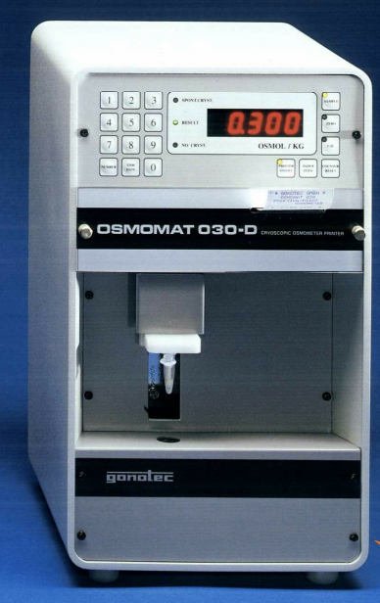 | OSMOMAT 030 CRYOSCOPIC OSMOMETER  50 mkL=0.05 mL of solution.  In these cases cryoscopy is used to determine the so-called osmotic concentration or osmolarity, C_{osm}, which can be directly inserted into Vant Hoff’s equation to calculate the value of osmotic pressure. This osmolarity is actually a sum of i•C products of all the solutes of solution: Cosm = i₁•C₁ + i₂•C₂ + i₃•C₃ + .... = Σ i_{k}•C_{k},  where
i_{k} is the isotonic coefficient of selected compound,
C_{k} is selected compound molar concentration.

Roul’s 2nd law for solution of one compound gives freezing point depression:
∆T_{freezing} = i•C_{m}•K_{cr}=K_{cr}•Σ i_{k}C_{k}=C_{osm}k_{cr}; and K_{cr} =1.86 (degree/m)

For a solution of several solutes, this equation becomes
0 º C- T_{freezing} =∆T_{freezing} =C_{osm}k_{cr}=C_{osm}•1.86 (degree)

CALCULATION OF OSMOTIC PRESSURE

Vant Hoff, who studied the dependence of osmotic pressure on the temperature and concentration, found out an analogy between osmotic pressure laws and gas laws. If we change the form of ideal gas equation:
pV = n·R·T
(p - pressure, V - volume, n - number of moles of gas , R - universal gas constant, T - temperature) in such a way, that volume is at its right side, we have:
The ratio gives the number of moles in a unit of volume i.e. the molar concentration. If one wants to use volume 1 litre as it is usually done in chemistry, one has to introduce a coefficient 1000 for calculation from m to liters: p = 1000 CM R T .
In such a way, the last form of ideal gas equation shows, that the pressure of gas is proportional to the molar concentration of gas and to temperature, the proportionality coefficient being R if volume is in m or 1000R if volume is measured in liters.
Vant Hoff found out, that osmotic pressure of solution is proportional to the molar concentration of solute and to temperature, having the same proportionality coefficient (R or 1000R), i.e. he showed, that the laws of osmotic pressure are similar to gas laws.
Vant Hoff’s law can be formulated as follows:
The osmotic pressure of a solution is numerically equal to the gas pressure, that would be observed, if the solute was in a gaseous form at the same temperature.
Mathematical expression of Vant Hoff’s law for non-electrolyte solutions is :
π = 1000 CMRT , (Pa)
In electrolyte solutions the osmotic pressure is caused by all solute particles and the concentration of solute particles is found as iCM therefore the expression of Vant Hoffs' law becomes:
π = 1000 iCMRT , (Pa)
The coefficient 1000 is inconvenient therefore it usually is not written, but one has to remember, that then osmotic pressure is calculated in kilo pascals (kPa) and not in pascals (Pa):.
π = iCMRT , (kPa)
Now, if ∆T_{freezing} is measured, value of C_{osm} can be determined without knowing the particular isotonic coefficients and concentrations of all solutes. Inserting C_{osm} into Vant Hoff’s law one calculates a correct value of osmotic pressure.
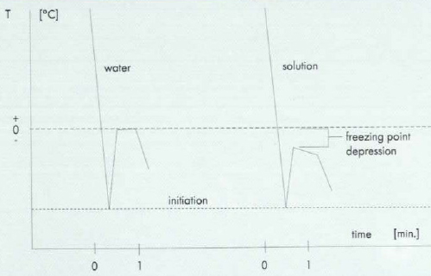
The osmotic pressure is: π = C_{osm} RT , (kPa)

Red blood cells at diferent OSMOMOLARITY in water solutions.
CHyperton>= 0,4 M; Cblood=0.305 M ; CHypoton=0 M <=0,2 M
Hypertonic salt Isotonic medium Hypotonic water distilled
ISOTONIC MEDIUM πin = πex ; Cin = Cex
If a cell is in an isotonic medium (having the same value of osmotic pres-sure and the same osmomolar concentrations), the flows of water in aquaporins into both directions are equal and the cell can normally exist.
To have the same osmotic pressure, than of human blood, medical solutions are diluted by the so-called physiological solution, which is 0.9% NaCl solution and is isotonic to human blood osmo molarity 0.305 M.
πin < πex ; Cin < Cex HYPERTONIC MEDIUM
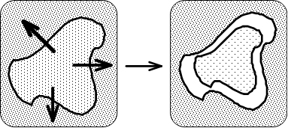 | If the cell is in a hypertonic medium (outer osmotic pressure is greater than the one inside the cell), the flow of water thru aquaporins is greater (if outer osmotic pressure is greater, the
concentration of solute in the outer solution is greater, too, and water molecules move into aquaporins from the less concentrated solution to the more concentrated one) and the cell looses water. The result is, that the outer layer of protoplasm contracts faster than the outer membrane and it tears off the membrane.
Hypertonic solutions, however, have medical applications. Hypertonic solutions are applied to purulent wounds, because hypertonic solution pumps water out of a wound and stimulates blood circulation in the wound. πin > πex ; Cin > Cex HYPOTONIC MEDIUM
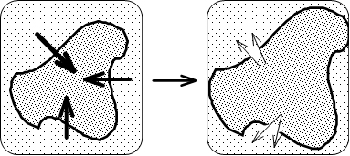 | If a cell is in a hypotonic medium (having a lower osmotic pressure, than the one inside the cell), the flow of water is greater towards the cell (as the concentration of solutes in the cell is
higher than outside), the cell puffs up until its membrane is broken.
Aquaporins are wide class of membrane crossing channel proteins, which are integrated in all living organisms: animals, plants, bacteria. On Cell membranes effecting Physiology, Biochemistry and Health. Aquaporins are large families (over 450 members) that are present in all kingdoms of life.
Concentration gradient osmolar difference:
H₂O+O_{2aqua}←^{Aquaporins}→O_{2aqua} +H₂O athermic ΔH=0 ^{kJ}/_{mol}.
Inside organism C_{osm}=0,305 and alveolar epithelia surface C=0.2 M drive O_{2aqua}, H₂O osmosis through aquaporins in to human body
ΔG_{aquaPor}=RTln([H₂O]_{right}/[H₂O]_{left})=
= -8,3144*310,15* ln(0,305/0,2)= -1.088 ^{kJ}/_{mol} exoergic - spontaneouse.

These channels, allow the passive but selective movement of Water and O₂, NO, CO across cell wall and subcellular membranes like as mitochondria, endoplasmic reticulum, peroxisomes, Golgi, lysosomes.
Aquaporins have been classified into two sub-families:
I) strict Aquaporins that only allow the passage of Water, O₂, NO, CO and II) the less selective aquaglyceroporins that transport Water and other neutral solutes , such as Glycerol, CO₂ or urea.
Recently, the identification and characterization of a number of archaeal and bacterial Aquaporins suggested the existence of a third sub-family; one that is neither a strict Aquaporin nor an aquaglyceroporin. The function and phylogeny of this third family is still a matter of debate.

Water channels H₂O common O₂, NO, CO: an overview in Human
AQP0 | + Cl–, NO₃– eye-lens cells; thin junctions between fiber cells  AQP0 with a measured Water permeability 15-fold lower than that of AQP1 at pH 6.5;  AQP0 is reduced a further three fold at pH 7.5  AQP0 induce a gating effect close conformations of extracellular loop A Met176,His40 AQP0 becomes more constrained near the conserved Ar/R constriction site
AQP1- | + Cl–, NO₃–,Aquaglyceroporins:red blood cell (RBC),  apical & basolateral membranes of epithelial brain cell, rodent brain cell  AQP1-null humans kidney proximal-tubule water reabsorption  gastrointestinal tract Water absorption in the teleost intestine  the ovary and in the oocyte ; salivary gland ;
AQP2 | urinary bladder granular kidney cells & subcellular  vasopressin regulated urine concentration (25% of the blood filtrate)  trans located from the cytoplasmic pool to the apical plasma membrane  of the granular cells of the pelvic patch and urinary bladder
AQP3 | +Aquaglyceroporins,urea:gastrointestinal tract Water absorption;rodent brain cell astrocyte end-feet  Water enters in the principal cell through AQP2 and exits through located in the basolateral membranes trachea basal AQP3 & ciliated columnar AQP4 cells
AQP4 | Rodent-brain;basolateral membrane of ciliated columnar cells alveolar epithelium;salivary gland
AQP5 | stomach, duodenum, pancreas, airways, lungs, salivary gland, sweat glands, eyes, lacrimal glands, and the inner ear tears & pulmonary sub mucosal glands secretions apical membrane& rodent brain cells
AQP6 | + Cl–, NO₃– multi permeable channel; lens cells; may play a role in the body acid–base homeostasis  in the intracellular vesicles of acid-secreting intercalated cells of the RCD colocalized with the H⁺-ATPase  be Hg²⁺-inhibit able Water channel function is activated by Hg²⁺ and low pH
AQP7 | + Aquaglyceroporins, urea; kidney proximal tubule epithelium cell  glycerol reabsorption ; together with AQP1 in the brush border  in the concentration of urine taking place in the proximal nephron  75% of the blood filtrate which is 150–180 L per day
AQP8 | NH₄⁺;lens & kidney intracellular proximal tubule & small intestine absorptive:epithelium cell  in the concentration of urine taking place in the proximal nephron also in mitochondria  75% of the blood filtrate which is 150–180 L per day & rodent brain cell
AQP9 | +Aquaglyceroporins, urea purines, pyrimidines & monocarboxylates, arsenite ;  apical membrane of brain & small intestine absorptive epithelial & rodent brain & glial cells
AQP10 | + Aquaglyceroporins, urea ; small intestine absorptive epithelial cells
AQP11 | “superaquaporins” or subcellular; kidney cytoplasm of the proximal tubule & rodent brain cells
AQP12 | “superaquaporins” or subcellular

bilipid membrane cross size 55Å | H₂O Channel is roughly 20-Å long and has a diameter 1.1 Å. Water channel proteins (WCPSs) are trans membrane proteins that have a specific three-dimensional structure with a pore the SF radius 1.1 Å is close average to radius of water H–O–H longetudinal 1.4 Å and 0.55 Å bent size of dipole.
It can be permeated by Water & O₂, NO, CO molecules as solutes. Aquaporins are large families (over 450 members) that are present in all kingdoms of life. Water permeability, allowing permeation through AQP1 monomer of 3 × 10⁹ water molecules per second and other, which strictly prevents Serine, Tyrosine, Threonine the conduction of protons H⁺.
Phosphorylation to trigger the membrane trafficking of AQP1, AQP2, AQP5, and AQP8, and the gating of AQP4. Cation conductance has been induced in AQP1 by activation of cyclic GMP–dependent pathways and was blocked by Hg²⁺ .
http://aris.gusc.lv/ChemFiles/Aquaporins/WCPsAQPsIUBMBlife09/AQP0-11.doc

