Proteins Aris Kaksis 2012. Riga Stradin’s University
I.3 Polypeptides and proteins http://aris.gusc.lv/NutritionBioChem/32Proteins.doc

In 1902, Emil Fischer proposed that proteins are long chains of amino acids joined together by amide bonds between the α-carboxyl group of one amino acids and the α-amino group of another. For these amide bonds, Fischer proposed the special name peptide bond. Figure below shows the peptide bond formed between glycine
and alanine in the dipeptide glycylalanine.  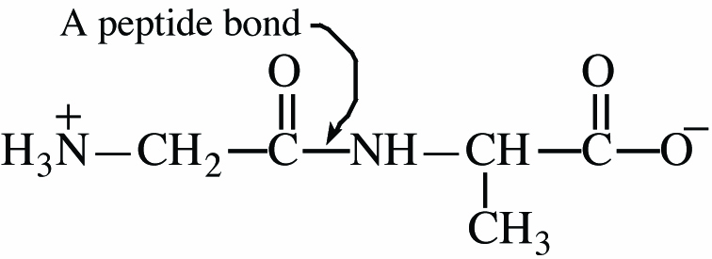  The peptide bond in glycylalanine | 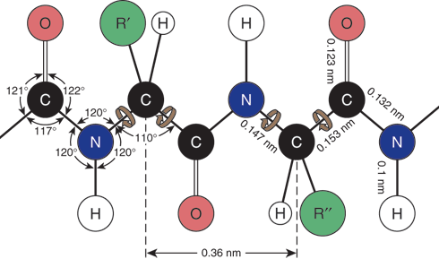
A molecule containing two amino acids joined by an amide bond is called a dipeptide. Those containing larger numbers of amino acids are called tripeptides, tetrapeptides, and pentapeptides and so on. Molecules containing 10 or more amino acids are generally called polypeptides. Proteins are biological macromolecules of molecular weight 5000 or greater, consisting of one or more polypeptide chains.
By convention, polypeptides are written from the left, beginning with the amino acids having the free H₃N⁺─ group and proceeding to the right toward H₃N⁺─ group is called the N-terminal amino acid and that with the free ⎯COO─ group is called the C-terminal amino acid. The structural formula for a polypeptide sequence may be written out in full or the sequence of amino acids may be indicated using the standard abbreviation for each.
N-terminal  H₃N⁺─  amino acid  ser - serine |  | ser—tyr—ala  (seryltyrosylalanine)  C terminal  ⎯COO─  amino acid  ala - alanine
Polypeptides are named by listing each amino acid in order, from the N-terminal end of the chain to the
C-terminal end. The name of the C-terminal amino acid is given in full. The name of each other amino acid in the chain is derived by dropping the suffix -ine or -ic and adding -yl. For example, if the order of amino acids from the N-terminal end is serine-tyrosine-alanine (ser-tyr-ala), the name of the tripeptide is seryltyrosylalanine.
Example I.4 Name and draw a structural formula for the tripeptide gly-ser-asp. Label the N-terminal amino
acid and the C-terminal amino acid. What is the net charge on this tripeptide at pH=6.0?
Solution In writing the formula for this tripeptide, begin with glycine to the α-amino group of serine by a peptide bond. Finally, connect the α-carbonyl of serine to the α-amino group of aspartic acid by another
peptide bond. If you have done this correctly, the backbone of the peptide chain be a repeating
sequence of nitrogen-alpha carbon-carbonyl. The net charge on this tripeptide at pH=6.0 is -1.
N-terminal  H₃N⁺─  amino acid  gly - glycine |  | gly — ser — asp  (glycylserylaspartic acid)  C terminal  ⎯COO─  Amino acid  asp - aspartic acid
Problem I.4 Name and draw a structural formula for lys-phe-ala. Label the N-terminal amino acid and the C-
terminal amino acid. What is the net charge on this tripeptide at pH=6.0?
I.4 Amino Acid Analysis

The first step in analyzing a polypeptide is hydrolysis and quantitative determination of its amino acid composition. Recall that amide bonds are very resistant to hydrolysis. Hydrolysis of polypeptides requires heating in 6M HCl at 110°C for 24-70 hr or heating 2-4M NaOH at comparable temperature and times. Once the polypeptide is hydrolyzed, the resulting mixture of amino acids is analyzed by ion-exchange chromatography. Amino acids are detected as they emerge from the column by reaction with ninhydrin (See previous). Current procedures for hydrolysis of polypeptides and analysis of amino acid mixtures have been refined to the point where it is possible to obtain amino acid composition from as little as 50 nanomoles (50•10—9 mol) of polypeptide. Figure I.5 shows the analysis of a polypeptide hydrolysate by ion exchange chromatography. Note that during hydrolysis, the side-chain amides of asparagine and glutamine are hydrolyzed and these amino acids are detected as glutamic acid and aspartic acid. For each glutamine or asparagine hydrolyzed, there is an equivalent amount of ammonia formed.
Absorbance 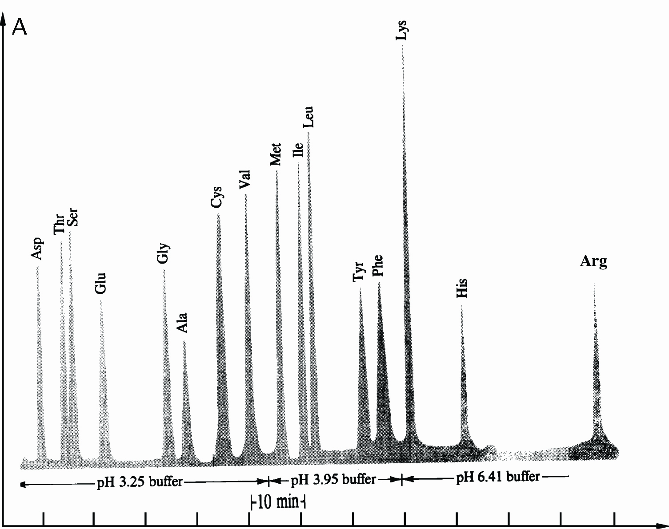
Time

Figure I.5 Analysis of mixture of amino acids by ion-exchange chromatography.

I.5 Primary Structure of Polypeptides and Proteins

Primary (1°) structure of polypeptides and proteins refers to the sequence of amino acids in a polypeptide chain. In this sense, primary structure is a complete description of all covalent bonding in a polypeptide or protein.
It is difficult to appreciate the incredibly large number of different polypeptides that can be constructed from 20 amino acids, where the number of amino acids in a polypeptide can range from under ten to well over a hundred. With only three amino acids, there are 27 different tripeptides possible. For glycine, alanine and serine, the 27 tripeptides are:
gly—gly—gly ser—ser—ser ala—ala—ala
gly—gly—ser ser—ser—gly ala—ala—gly
gly—gly—ala ser—ser—ala ala—ala—ser
gly—ser—gly ser—gly—ser ala—gly—ala
gly—ala—gly ser—ala—ser ala—ser—ala
gly—ser—ala ser—gly—ala ala—gly—ser
gly—ala—ser ser—ala—gly ala—ser—gly
gly—ser—ser ser—gly—gly ala—gly—gly
gly—ala—ala ser—ala—ala ala—ser—ser

Statistical analyze of human protein average polypeptide chain length shows number Npeptide = 184 of the
20 = nAA different amino acids (Combinations-Variations) Comb, the number of possible polypeptides is

= 9 ; = 4
= 1.9•10240 truly countless variation-combination of
20 amino acids arrangement on the polypeptide chain starting from N-terminal and finishing on C-terminal.
184 = Npeptide

I.6 Three-Dimensional Shapes of polypeptides and Proteins A. Geometry of a Peptide Bond

In the late 1930s, Linus Pauling began a series of studies designed to learn more about the three-dimensional shapes of proteins. One of his first discoveries was that a peptide bond itself is planar. As shown in Figure I.6, the four atoms of a peptide bond ⎯CO⎯HN⎯ and the two alpha-carbons joined to it all lie in the same plane
Had you been asked earlier to predict the geometry of a peptide bond, you probably would have reasoned in the following way. There are three bundles of electron density around the carbonyl carbon; therefore predict bond angles of 120° about the carbonyl carbon. There are four bundles of electron density around the amide nitrogen; therefore predict bond angles of 109.5° about this atom. These predictions agree with the observed bond angles of approximately 120° about the carbonyl carbon. However, a bond angle of 120° about the amide nitrogen is unexpected. To account for this observed geometry, Pauling proposed that a peptide bond is more accurately represented as a resonance hybrid of two important contributing structures:
I ↔ II
Figure I.6 Planarity of a peptide bond. Bond angles about the carbonyl carbon and the amide nitrogen are
approximately 120°.

Contributing structure I show C=O double bond and a C—N single bond. Structure II shows a C—O single bond and a C=N double bond. If structure I is the major contributor to the hybrid, the C—N—C bond angle would be nearer 109.5°. If, on the other hand, structure II is the major contributor, the C—N—C bond angle would be nearer 120°. The fact, first observed by Pauling, is that the C—N—C bond angle is very near 120°, which means that the peptide bond is planar and structure II is the major contributor to the resonance hybrid.
Two configurations are possible for the atoms of a planar peptide bond. In one configuration, the two
α-carbons are cis to each other; in the other, they are trans to each other:
trans cis
The trans configuration is more favorable because the bulky α-carbons are farther from each other than they are in the cis configuration. Virtually all peptide bonds in natural proteins have the trans configuration.
B. Secondary Structure

Secondary (2°) structure refers to ordered arrangements (conformation) of amino acids in localized regions of a polypeptide or protein, molecule. The first studies of polypeptide conformations were also carried out by Linus Pauling and Robert Corey, beginning in 1939. They assumed that in conformations of greatest stability,
(1) all atoms in a peptide bond lie in the same plane and (2) each amide group is hydrogen-bonded between the
N—H of one peptide bond and the C=O of another, as shown in Figure I.7. On this basis of model-building, Pauling and Corey proposed that two folding patterns should be particularly stable: the α-helix and the antiparallel -pleated sheet. In the -helix pattern shown in Figure I.7, a polypeptide chain is coiled in a spiral.
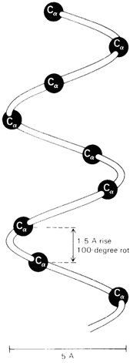a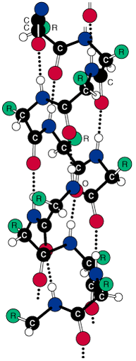b | C terminal amino acid on polypeptide chain end has free carboxyl group  ⎯COO─  carbon atom  oxygen atom  hydrogen atom  nitrogen atom  amino acid residue side chain  N-terminal  ─⁺NH₃  amino acid
Figure I.7 (a) A right-handed α-helix space-filling α-C model on the carbon-nitrogen backbone trace
of an α-helix. (b) Ball-and-stick model of an α-helix showing intra chain hydrogen bonds •••.
α-helix in one turn has 3.6 amino acid residues and one step amino acid turn stage have 1.5 Å and 100 º angle.

As you study the α-helix in Figure I.7, note the following:
1. The helix is coiled in a clockwise or right-handed manner. Right-handed means that if you turn the helix clockwise, it twists away from you. In this sense, a right-handed helix is analogous to the right-hand thread of a common wood or machine screw.
2. There are 3.6 amino acids per turn of the helix.
3. Each peptide bond is trans and planar.
4. The N—H group of each peptide bond points roughly upward, parallel to the axis of the helix; and the C=O of each peptide bond points roughly downward, also parallel to the axis of helix.
5. The carbonyl group of each peptide bond is hydrogen-bonded to the N—H group of the peptide bond four amino acid units away from it. Hydrogen bonds are shown as dotted lines.
6. All R— groups point outward from the helix.
Almost immediately after Pauling proposed the α-helix structure, other researchers proved the presence of
α-helix in keratin, the protein of hair and wool. It soon became obvious that the α-helix is one of the fundamental folding patterns for secondary structure 2º of polypeptide chains.
β-pleated sheets consist of extended polypeptide chains with neighboring chains running in opposite (antiparallel) directions. Unlike the α-helix arrangement, N—H and C=O groups lie in the sheet and are roughly perpendicular to the long axis of the sheet. The C=O group of each peptide bond is hydrogen-bonded to the
N—H group of a peptide bond of a neighboring chain C=O- - -H—N.
H₃⁺N— Amino terminus ——→ Polypeptide chain ——→ Carboxyl terminus —COO-
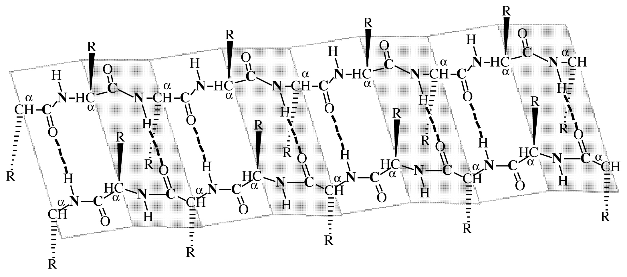
-OOC— Carboxyl terminus ←—— Polypeptide chain ←—— Amino terminus —⁺NH₃
Figure I.8 β-pleated sheet conformation with two polypeptide chains running in opposite (antiparallel)
directions. Hydrogen bonding between chains is indicated by dotted lines C=O- - -H—N.

As you study the secondary 2º structure of β-pleated sheet shown in figure I.8, note the following:
1. The two polypeptide chains lie adjacent to each other and run in opposite (antiparallel) directions.
2. Each peptide bond is trans and planar.
3. The polypeptide is a chain of flat or planar sections connected at amino acid α-carbons.
4. The C=O and N—H groups of peptide bonds from adjacent chains point at each other and are in the same plane, so hydrogen bonding is possible between adjacent polypeptide chains.
5. The R— groups on any one chain alternate, first above the plane of the sheet and below the plane of the sheet.
The pleated sheet conformation is stabilized by hydrogen bonding between N—H groups of one chain and C=O groups of an adjacent chain C=O- - -H—N. By comparison, the α-helix is stabilized by hydrogen bonding between N—H and C=O groups within the same polypeptide chain.
Secondary 2º structure is used to describe α-helix, -pleated sheet and other types of periodic conformations in localized regions of polypeptide or protein molecules like as beta turns or loops as well bents.
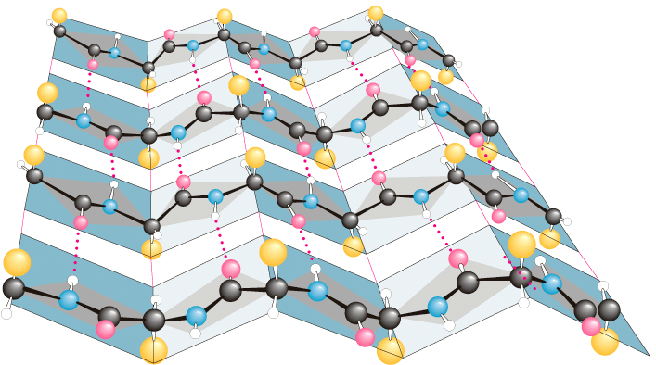 | carbon atom  oxygen atom  hydrogen atom  nitrogen atom   amino acid residue side  chain

Loops, Turns & Bends

Roughly half of the residues in a "typical" globular protein reside in α-helices and β-sheets but second half in loops, turns, bends and other extended conformational features. Loops, turns and bends refer to short segments of amino acids that join two units of secondary structure, such as two adjacent strands of an antiparallel β-sheet. A β-turn involves four aminoacyl residues, in which the first residue is hydrogen-bonded to the fourth, resulting in a tight 180-degree turn (Figure 5–7). Proline and glycine often are present in β-turns.
Figure I.8A A β-turn that links two segments of anti-parallel β-sheet. The dotted line indicates the hydrogen bond between the first and fourth amino acids of the four-residue segment Ala-Gly-Asp-Ser.

The term secondary structure is used to describe α-helix, β-pleated sheet and β-turns of periodic conformations in localized regions of polypeptide or protein molecules.

C. Tertiary Structure

Tertiary (3°) structure refers to the overall folding pattern and arrangement in space of all atoms in a single polypeptide chain. Actually, there is no sharp dividing line between secondary and tertiary structure. Secondary structure refers to the spatial arrangement of amino acids close to one another on a polypeptide chain and tertiary structure refers to the three-dimensional arrangement of all atoms of a polypeptide chain.
Disulfide bonds (Section of Thiols) are important in maintaining tertiary structure. Disulfide bonds are formed between side chains of cysteine by oxidation of two thiol groups (Cys⎯SH) to form the disulfide bond (Cys⎯S⎯S⎯Cys) , as shown for cysteine containing polypeptide parts:
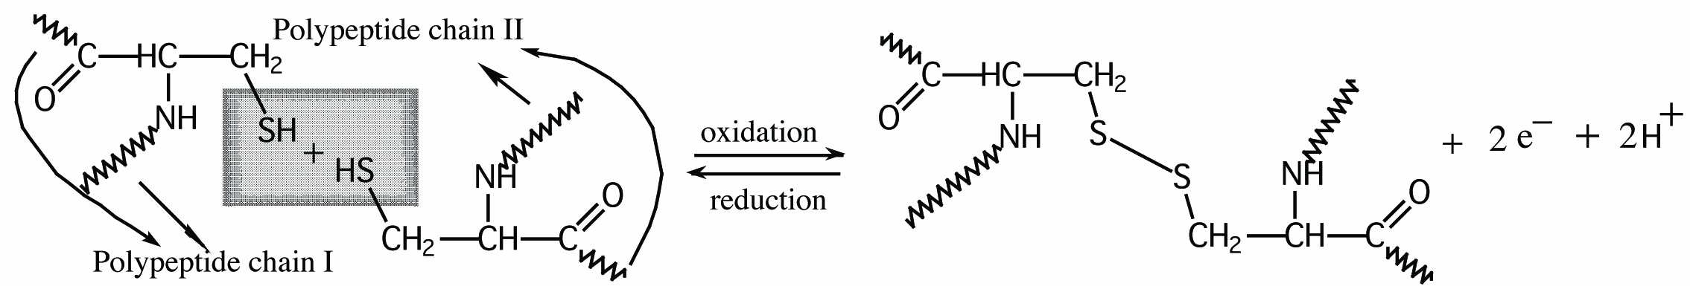
cysteine units on adjacent polypeptide chains disulfide bond (bridge) between cysteine thiol groups

Treatment of a disulfide bond with a reducing agent regenerates the thiol group that is reduction.

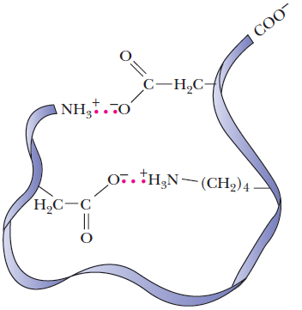 | Intra molecular ionic bonds between oppositely charged groups on amino acid residues in a protein like as salt bridge indeed, for example, of aspartic acid salt and lysine positive charged basic amino group Asp⎯COO-…H₃⁺N⎯Lys  Salt bridge forms between negative charged carbonic acid salt and positive charged neighbor on protein chains ammonium functional groups COO-H₃⁺N and is one of five  intermolecular forces :
  1. Hydrogen bonds,
  2. Salt bridge,
  3. Disulfide bonds,
  4. Hydrophobic bonds and
  5. Coordinative bonds.
Three-dimensional structure of myoglobin protein found in skeletal muscle and particularly abundant in diving mammals such as seals, whales and dolphins. Myoglobin stores molecular oxygen for metabolic oxidation.
Myoglobin consists of a single polypeptide chain of 153 amino acids from Val1 to Gly153. The complete amino acid sequence (primary structure) of the chain is known. Myoglobin also contains a single heme unit.
Determination of the three-dimensional structure of myoglobin represented a milestone in the study of molecular architecture. J. C. Kendrew, for his contribution to this research, shared the Nobel Prize in chemistry in 1963. The secondary and tertiary structure of myoglobin is shown in Figure I.9. The single polypeptide chain is folded into a complex, almost box like shape.

Figure I.9 The three-dimensional structure of myoglobin. The heme group is shown as on one plane disposed symmetrical joined adjacent polygons like to grill railings. The N-terminal amino acid (indicated by —NH3+) is at the lower left and the C-terminal amino acid (indicated by—CO2-) is at the upper left.

A more detailed analysis has revealed the exact location of all atoms of the peptide on backbone trace and also a location of all side chains.
The four important structural features of myoglobin are:
1. The backbone consists of eight relatively straight sections of α-helix A, B, C, D, E, F, G, H, each separated by a β-bend in the polypeptide chain. The longest section of α-helix has 23 amino acids, the shortest has 7. Some 75% of the amino acids are found in these eight regions of α-helix.
2. Hydrophobic side chains, such as those of phenylalanine, alanine, valine, leucine, isoleucine and methionine are clustered in the interior of the molecule, which shield oxygen O2 from contact with water and hydroxonium ions H3O+. Hydrophobic interactions between nonpolar side chains are important in directing the folding of the polypeptide chain of myoglobin into this compact, three-dimensional shape.
3. The outer surface of myoglobin is coated with hydrophilic side chains, such as those of lysine, arginine, serine, glutamic acid, histidine and glutamine, which interact with the aqueous environment create water soluble hydrate coat. The only polar side chains that point to the myoglobin molecule are those of two histidines. These side chains can be seen in Figure I.9 as five-member single rings pointing inward toward the heme group.
4. Oppositely charged amino acids close to each other in the three-dimensional structure interact by electrostatic attractions called salt linkages or salt bridges. An example of a salt bridge is the attraction of the side chains of lysine amino—NH3+ and glutamic acid carboxylic —CO2- groups.
The tertiary structures of several other globular proteins have also been determined. It is clear that globular proteins contain α-helix and β-pleated sheet structures and also that the relatively amounts of each vary widely. Lysozyme, with 129 amino acids in a single polypeptide chain, has only 25% of its amino acids in α-helix regions. Cytochrome, with 104 amino acids in a single polypeptide chain, has no α-helix structure but does contain several regions of β-pleated sheet. Yet, whatever the proportions of α-helix, β-pleated sheet or other periodic structure, virtually all nonpolar side chains of globular proteins are directed toward the interior of the molecule, while polar side chains are on the surface of the molecule and are in contact with the aqueous environment. Thus the same type of hydrophobic/hydrophilic interaction that are responsible for formation of soap micelles (See Surface active compounds) and phospholipid bilayers (Will see on next lecture) are responsible for the three-dimensional shapes of globular proteins.
Example I.5 With which of the following amino acid side chain can the side chain of threonine form hydrogen bonds? a. valine b. asparagine c. phenylalanine d. histidine e. tyrosine f. alanine . Solution The side chain of threonine contains a hydroxyl group —OH that can participate in hydrogen bonding in two ways: oxygen has a partial negative charge and can function as a hydrogen bond acceptor; hydrogen has a partial positive charge and can function as a hydrogen bond donor. Therefore, the side chain of threonine can function as a hydrogen bond acceptor for the side chain of tyrosine, asparagine and histidine. The side chain of threonine can also function as a hydrogen bond donor for the side chains of tyrosine, asparagine and histidine.
Problem I.5 At pH=7.4, with amino acid side chains can the side chain of lysine form salt linkages?
D. Quaternary 4º Structure

Most proteins of molecular weight greater than 50 000 consist of two or more with five 5 intermolecular forces linked polypeptide chains. The arrangement of protein monomers in an aggregation is known as quaternary (4°) structure. A good example is hemoglobin, a protein that consist of four separate protein monomers: two α-chains of 141 amino acids each and two β-chains of 146 amino acids each. The quaternary (4°) structure of hemoglobin is shown in Figure I.11.
beta chains
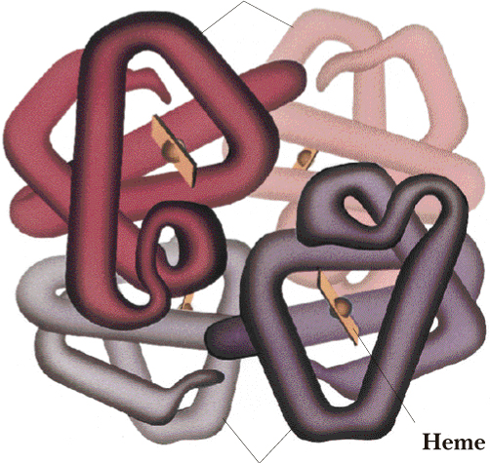
alpha chains
Figure I.11 The quaternary (4°) structure of hemoglobin, showing the four subunits packed together. The flat disk represent four heme units.

The chief factor stabilizing the aggregation of protein subunits is hydrophobic interaction. When separate monomers fold into compact three-dimensional shapes to expose polar side chains to the aqueous environment and shield non-polar side chains from water, there are still hydrophobic "patches" on the surface, in contact with water. These patches can be shield from water if two or more monomers assemble so their hydrophobic patches are in contact. The molecular weights, numbers of subunits and biological functions of several proteins with quaternary (4°) structure are shown in Table I.7

Table I.7  Quaternary | Protein | Mol.Wt. | Number  of Subunits | Subunit  Mol.Wt. | Biological Function
structure  of selected  proteins. | insulin  hemoglobin  alcohol dehydrogenase  lactate dehydrogenase  aldolase  fumarase  tobacco mosaic virus | 11 466  64 500  80 000  134 000  150 000  194 000  40 000 000 | 2  4  4  4  4  4  2280 | 5 733  16 100  20 000  33 500  37 500  48 500  17 500 | a hormone regulating  glucose metabolism  oxygen transport in blood plasma  an enzyme of alcoholic  fermentation  an enzyme of anaerobic glycolysis  an enzyme of anaerobic glycolysis  an enzyme of the tricarboxylic acid Krebs cycle  plant virus coat
single stranded RNA helix containing 6390 nucleotides
protein subunit 3000 Å
←⎯⎯⎯⎯ 180 Å ⎯⎯⎯⎯⎯→
Figure I.12a The quaternary structure of tobacco mosaic virus built up from 2200 protein subunits and
wrapping up the informative chain of ribonucleic acids RNA, particularly built in quaternary helical symmetry structure of proteins like to hollow cylinder 3000 Å long size and 180 Å external diameter size.
Figure I.12b The quaternary structure of polio virus capsids built up from protein subunits stuck in icosahedral rotational symmetry by 300 Å size and wrapping up the informative chain of ribonucleic acids RNA,
particularly built in quaternary structure of proteins.

E. 1° Structure Determines 2°, 3° and 4° Structure

The primary structure of a protein is determined by information coded within genes. Once the primary structure of a polypeptide is established, the structure itself directs the folding of the polypeptide chain into a three-dimensional structure. In the other words, information inherent in the primary structure of a protein determines its secondary, tertiary and quaternary structures.
If three-dimensional shape of a polypeptide or protein is determined by its primary structure, how can we account for the observation that denaturation is irreversible for some proteins and not others?
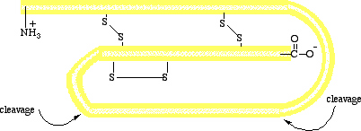
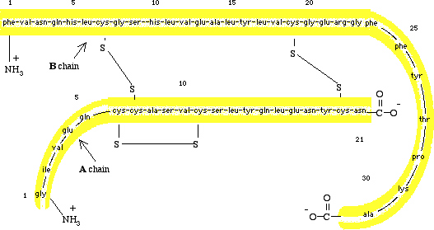
Figure I.13 (Top) A schematic diagram of pro insulin, a single polypeptide chain of 84 amino acids.
(Bottom) The amino acid sequence of bovine insulin.

The reason for this difference in behavior from one protein to another is that some proteins, like ribonuclease, are synthesized as single polypeptide chains, which then fold into unique three-dimensional structures with full biological activity. Others, like insulin, are synthesized as larger molecules that are not biologically active at first but "activated" later by specific enzyme-catalyzed peptide-bond hydrolize. Insulin is synthesized in the beta cells of the pancreas as a single polypeptide chain of 84 amino acids. This molecule, called pro insulin, has no biological activity. When insulin is needed, a section of 33 amino acids is hydrolyzed from pro insulin in an enzyme-catalyzed reaction to produce the active hormone (Figure I.13). Bovine insulin contains 51 amino acids in two polypeptide chains. The A chain contains 21 amino acids and has glycine (Gly[G])at the —NH3+ terminus and asparagine (Asn[N]) at the —COO- terminus. The B chain contains 30 amino acids with phenylalanine (Phe[F]) at the —NH3+ terminus and alanine (Ala[A]) at the —COO- terminus.
Because the information directing the original folding of the single polypeptide chain of pro insulin is not present in the A and B chains of the active hormone, refolding of the denatured protein is irregular and denaturation is irreversible.
Zymogens are enzyme produced as inactive proteins, which are then activated by hydrolize of one or more of the polypeptide bonds. The process of producing a protein in an inactive, storage form is common. For example, the digestive enzymes trypsin and chymotrypsin are produced in the pancreas as inactive proteins, named trypsinogen and chymotrypsinogen. There is a logical and simple reason for the synthesis of zymogens. In the case of trypsin and chymotrypsin, their function is to catalyze the hydrolysis of dietary proteins reaching the intestinal track. Proteins there are hydrolyzed to their component amino acids and then absorbed through the wall of the intestine into bloodstream. If trypsin and chymotrypsin were produced as active enzyme, they might well catalyze their own hydrolysis as well as that of other proteins in the pancreas-in effect, a "self-destruct" system. But nature has protected against this happening by synthesizing and storing zymogens instead.

F. Denaturation

Globular proteins found in living organisms are remarkably sensitive to changes in environment (pH, T, SAC, solvent composition, mechanical treatment, urea). Relatively small changes in pH, temperature or solvent composition, even for only a short period, may causes them to become denatured. Denaturation causes mechanical-physical activity. Except for cleavage of disulfide and coordinative bonds, denaturation stems from changes in secondary, tertiary or quaternary structure through disruption of non covalent intermolecular interaction forces, such as hydrogen bonds, salt linkages and hydrophobic bonds. Common denaturing agents include the following:
1. Heat. Most globular proteins become denatured when heated above T > 50-60° C. For example, boiling or frying an egg causes egg-white and yolk proteins to become denatured, forming an insoluble mass.
2. Large change in pH. Adding concentrated acid or alkali to a protein in aqueous solution causes changes in the charged character of ionizable side chains and interferes with salt linkages. For example, in certain clinical chemistry tests where it is necessary first to remove any protein material, trichloroacetic acid (a strong organic acid) is added to denature and precipitate any protein present.
3. Detergents. Treating a protein with surface active compounds (SAC) like as sodium dodecylsulfate (SDS), (See next lecture), a detergent, causes the native conformation to unfold and exposes the nonpolar protein side chains to the aqueous environment. These side chains are then stabilized by hydrophobic interaction with hydrocarbon chains of the detergent.
4. Organic solvents such as alcohols, acetone or ether.
5. Mechanical treatment. Most globular proteins are denatured in aqueous solution if they are stirred or shaken vigorously. An example is whipped egg whites to cook beze biscuits or pudding.
6. Urea and guanidine hydrochloride cause disruption of protein hydrogen bonding and hydrophobic interactions. Because urea is a small molecule with a high degree of polarity, it is very soluble in water. A solution of 8M urea (480 g urea/L of water) is commonly used to denature proteins. Guanidine is a derivative of urea in which >C=O is replaced by =NH. Guanidine is a strong base and reacts with HCl and to form the salt guanidine hydrochloride.
urea guanidine guanidine hydrochloride

Denaturation can be partial or complete. It can also be reversible or irreversible. For example, the hormone insulin can be denatured with 8M urea and then the three disulfide bonds Cys—S—S—Cys reduced to six free Cys—SH groups. If urea is then removed and the disulfide bonds re-formed by oxidation, the resulting molecule has less than 1% of its former biological activity. In this case, denaturation is both complete and irreversible. Consider another example, ribonuclease, an enzyme that consist of a single polypeptide chain of 124 amino acids folded into a compact, three-dimensional structure partly stabilized by four disulfide bonds Cys—S—S—Cys. Treatment of ribonuclease with urea causes the molecule to unfold, and the disulfide bonds can then be reduced to thiol groups Cys—SH. At this point, the protein is completely denatured-it has no biological activity. If urea is removed from solution and the thiol groups Cys—SH reoxidized to disulfide bonds Cys—S—S—Cys, the protein regains its full biological activity. In this instance, denaturation has been complete but reversible.
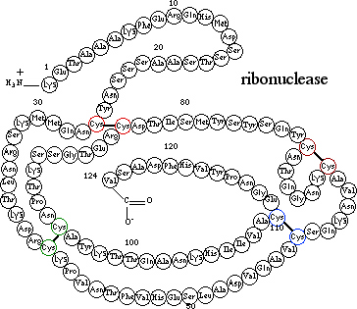
Figure I.13 Structure of biologically active enzyme: the ribonuclease.
Denaturation of ribonuclease by reducing agent and oxidation by oxidizing agent.
I.7 Fibrous Proteins
Fibrous proteins are stringy, physically tough macromolecules composed of rod like polypeptide chains joined together by several types of cross-linkages to form stable, insoluble structures. The two main classes of fibrous proteins are the keratins of skin, wool, claws, horn and feathers and the collagens of the tendon and hides.

A. The Alpha-Keratins
Hair and wool are very flexible and also elastic, so when tension is released, the fibers revert to their original length. At the molecular level, the fundamental structural unit of hair is a polypeptide wound into an α-helix conformation (Figure I.14). Several levels of structural organization are built from simple α-helix. First, three strands of α-helix are twisted together to form a larger cable called a protofibril. Protofibrils are then wound into bundles to form an 11-strand cable called a micro fibril. These, in turn, are embedded in a larger matrix that ultimately forms a hair fiber (Figure I.14). When hair is stretched, hydrogen bonds along turns of each α-helix are elongated. The main force causing stretched hair fibers to return to their original length is re-formation of hydrogen bonds in the α-helices.
The α-keratins of horns and claws have essentially the same structure as hair but with a much higher concentration of cysteine (Cys) and greater degree of disulfide cross-linking Cys—S—S—Cys between individual helices. These additional disulfide bonds Cys—S—S—Cys greatly increase resistance to stretching and produce the hard keratins of horn and claw.
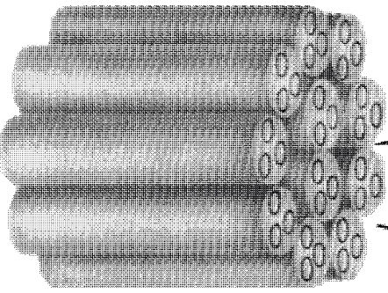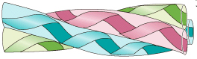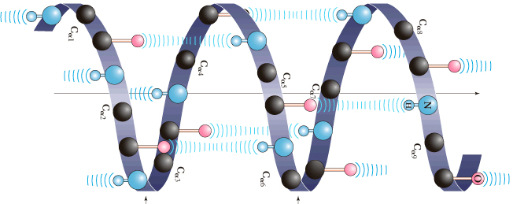
Micro fibril Protofibril α-Helix
Figure I.14 Detailed structure of a hair fiber.
B. Collagen Triple Helix

Collagens are constituents of skin, bone, teeth, blood vessels, tendons, cartilage and connective tissue. They are the most abundant protein in higher vertebrates and make up almost 30% of total body mass in humans.
Table I.8 lists the collagen content of several tissues. Note that bone, the Achilles tendon, skin, and the cornea of the eye are largely collagen.
Table I.8  Collagen content | Tissue | Collagen  (% Dry Weight) | Tissue | Collagen  (% Dry Weight)
of some body  tissues | bone, mineral-free  Achilles tendon  skin  cornea | 88  86  72  68 | cartilage  ligament  aorta | 46-63  17  12-24

Because collagen is abundant and widely distributed in vertebrates and because it is associated with a variety of diseases and problems of aging, more is known about this fibrous protein than about any other. Collagen molecules are very large and have a distinctive amino acid composition. One-third of all amino acids in collagen are glycine and another 21% are either hydroxylysine or hydroxyproline (See former amino acids). Both hydroxylated amino acids are formed after their parent amino acids (L-proline and L-lysine) and incorporated in collagen molecules. Because cysteine is almost entirely absent, there are no disulfide cross-links in collagen. When collagen fibers are boiled in water, they are converted to insoluble gelatins.
The polypeptide chains of collagen fold into a conformation that is particularly stable and unique to collagen. In this conformation, three protein strands wrap around each other to form a left-handed super helix called the collagen triple helix. This unit, called tropocollagen, looks much like a three-stranded rope (Figure I.15).
The hydroxyl groups of hydroxyproline and hydroxylysine residues help to maintain the triple helix structure by forming hydrogen bonds >C=O•••H—N< between adjacent chains. Fibers in which proline and lysine groups have not been hydroxylated are far less stable than fibers in which these groups have been hydroxylated. one of the important functions of vitamin C is in hydroxylation of collagen. Without adequate supplies of vitamin C, collagen metabolism is impaired, giving rise to scurvy, a condition in which tropocollagen fibers do not form stable physically tough fibers. Scurvy produces skin lesions, fragile blood vessels and bleeding gums.
Collagen fibers are formed when many tropocollagen molecules line up side by side in regular pattern and are then cross-linked by newly formed covalent cross-bonds. Most covalent cross-linking involves the side chains of lysines. The extent and type of cross-linking vary with age and physiological condition. For example, the collagen of rat Achilles tendon is highly cross-linked and collagen of the more flexible tendon of rat tail is less highly cross-linked. Further, it is not clear when, if ever, the process of cross-linking is completed. Some believe it continues throughout life, producing increasingly stiffer skin, blood vessels and other tissues, which then contribute to the medical problems of aging and the aged, making more fragile bones and tissues.
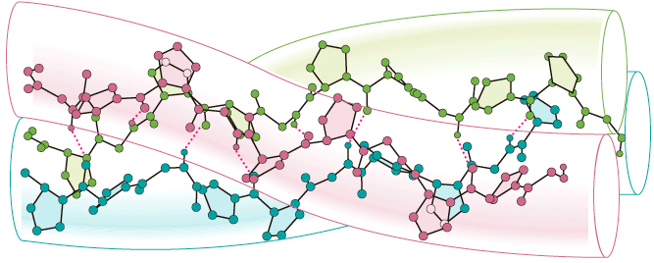 | Figure I.15 Collagen  triple helix.
I.8 Plasma Proteins: Examples of Globular Proteins
Human blood consists of a fluid water solution portion (plasma) and cellular components. The cellular components, which make up 40-50% of volume of whole blood, consist of red blood cells (erythrocytes), white blood cells (leukocytes) and blood platelets (trombocytes). Human plasma consist largely of water (90-92%) in which are dissolved various inorganic ions and a heterogeneous mixture of organic molecules, the largest groups of which are the plasma proteins. The earliest method of separating plasma proteins into fractions used ammonium sulfate to "salt out" different types of proteins. The fraction precipitated from plasma 50% saturated with ammonium sulfate was called globulin. The fraction not precipitated at this salt concentration but precipitated from plasma saturated with ammonium sulfate was called albumin. Today, electrophoresis is the most common method of separating proteins of biological fluids into fractions, especially in the clinical laboratory, where it is used routinely to measure proteins in human plasma, urine and cerebrospinal fluid. It is estimated that between 15 and 20 million plasma-protein electrophoretic analyses are carried out each year in the United States and Canada.
In plasma-protein electrophoresis, a sample of plasma is applied as a narrow line to a cellulose acetate strip. The ends of the strip are then immersed in a buffer of pH 8.8 and a voltage is applied to the strip. At pH 8.8, plasma proteins have net negative charges and migrate toward the positive electrode. After a predetermined time, the cellulose acetate strip is removed, dried and sprayed with a dye that selectively stains proteins. The separated protein fractions then appear on the developed strip as spots (Figure I.16 (a) ). The amount of protein in each spot is determined using a densitometer to measure intensity versus width of each peak.
(a) Positive  electrode  (b) | Proteins move in this direction  ←⎯⎯⎯⎯⎯⎯ Origin  Albumin Globulins | Negative  electrode  Figure I.16 Separation of serum proteins by electrophoresis. (a) A sample is applied as a narrow line at the origin. After electrophoresis at pH 8.8, the paper is dried and stained. (b) A plot of color intensity of each spot.
Electrophoresis on cellulose acetate separates serum proteins into five large fractions: one albumin fraction and four globulin fractions. The four globulin fractions are arbitrarily designated α1, α2, β and γ according to their electrophoretic mobilities. Serum albumin has an isoelectric point of about pH 4.9 and migrates farthest toward the positive electrode. Gamma-globulin has an isoelectric point of about pH 7.36 and migrates the shortest distance. Shown in table I.9 are the concentrations of the five large protein fractions of human serum.
Table I.9  Concentrations of | Fraction | (g/100 mL) | Total  Protein % | The primary function of albumins is to regulate the osmotic pressure of blood. In addition, albumins are important fatty acids and certain drugs such as aspirin and digitalis. The α1 and α2 fractions transport other biomolecules, such as fats, steroids and phospholipids and various other lipids.
the important  human serum  proteins as  determined by  electrophoresis. | albumin  globulins  α1  α2  β  γ | 3.5-5.0  0.1-0.4  0.5-1.1  0.6-1.2  0.5-1.5 | 52-67  2.5-4.5  6.6-13.6  9.1-14.7  9.0-21.6
The α1 fraction also contain antitrypsin, a protein that inhibits the protein-digesting enzyme trypsin. The α 2 fraction contains haptoglobulin, which binds any hemoglobin released from destroyed red blood cells and ceruloplasmin, the principal copper-containing protein of the body. The α2 fraction also contains prothrombin, an inactive form of the blood-clotting enzyme thrombin. The β fraction contains a variety of specific transport proteins, as well as substances involved in blood clotting.
The γ-globulin fraction consists primarily of antibodies (immunoglobulins), whose function is to combat antigens (foreign or undesirable proteins for organism) introduced into the host body. Specific antibodies are formed by the immune system in response to specific antigens. The response is the basis for immunization against such infectious diseases as polio, tetanus and diphtheria. An antibody consist of a combination of two heavy (high-molecular-weight) and two light (low-molecular-weight) polypeptide chains held together by four disulfide bonds Cys⎯S⎯S⎯Cys (Figure I.17). Each antibody has two identical binding sites paratops that react with specific antigens to form an insoluble complex called precipitin. Formation of precipitin deactivates the antigen and permits its removal and breakdown by white blood cells (leucocytes-macrophages).
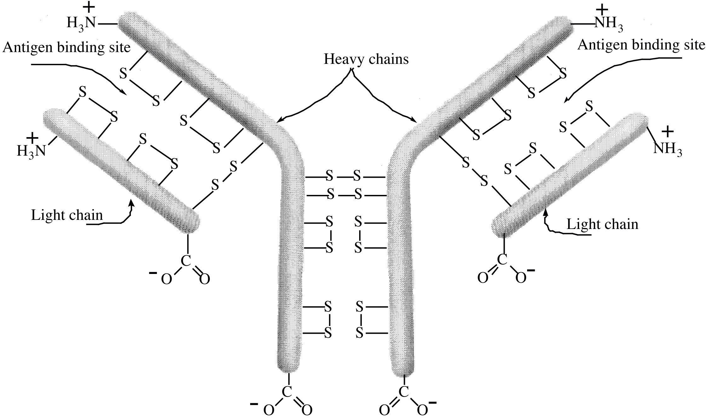
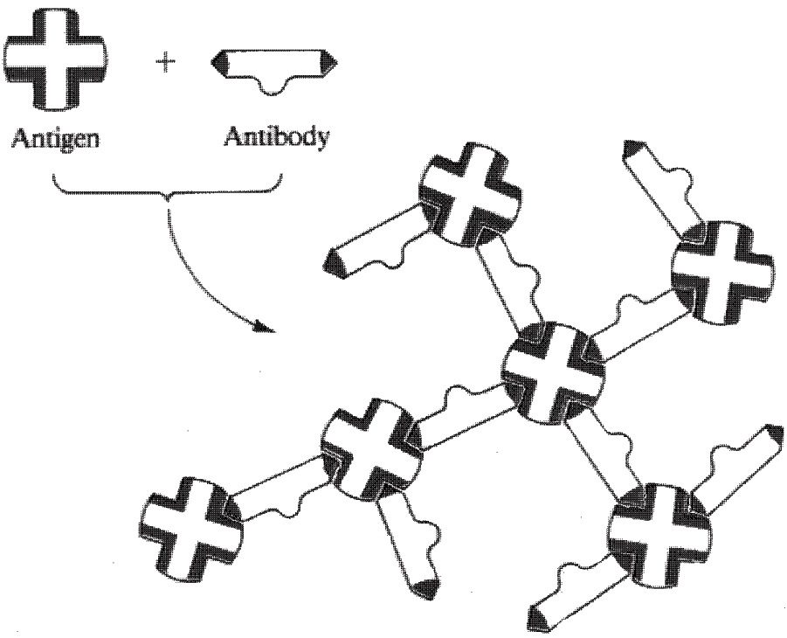
Precipitin complex (insoluble)
Figure I.17 The projection of three-dimensional shape antibody. The iteraction between antibody and its specific antigen to form an inactive precipitin complex. The precipitated antigen-antibody complex is then ingested and broken down whit blood cells.

